Sources: <https://www.w3schools.com/css/css_intro.asp>

What is CSS?

CSS stands for Cascading Style Sheets

CSS describes how HTML elements are to be displayed on screen, paper, or in other media

CSS saves a lot of work. It can control the layout of multiple web pages all at once

External stylesheets are stored in CSS files

Sources: <https://fileinfo.com/extension/css>

What is a CSS file?

A CSS file is a cascading style sheet (CSS) file used to format the contents of a webpage. It contains customized, global properties for how to display HTML elements. CSS files can define the size, color, font, line spacing, indentation, borders, and location of HTML elements.

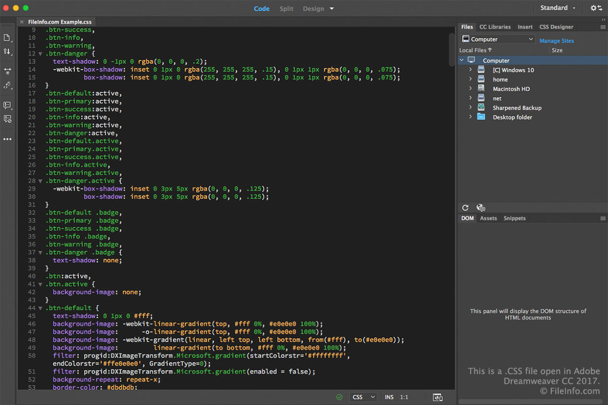

C:\Users\KS\AppData\Roaming\Tencent\Users\766686275\QQ\WinTemp\RichOle\]I6J2FMN`]V]W1FWBWFW[NY.pngNotepad++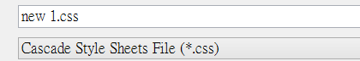

CSS files are used to create a similar look and feel across websites. They also are used to reduce the amount of work and HTML code generated by consolidating display properties into a single file.

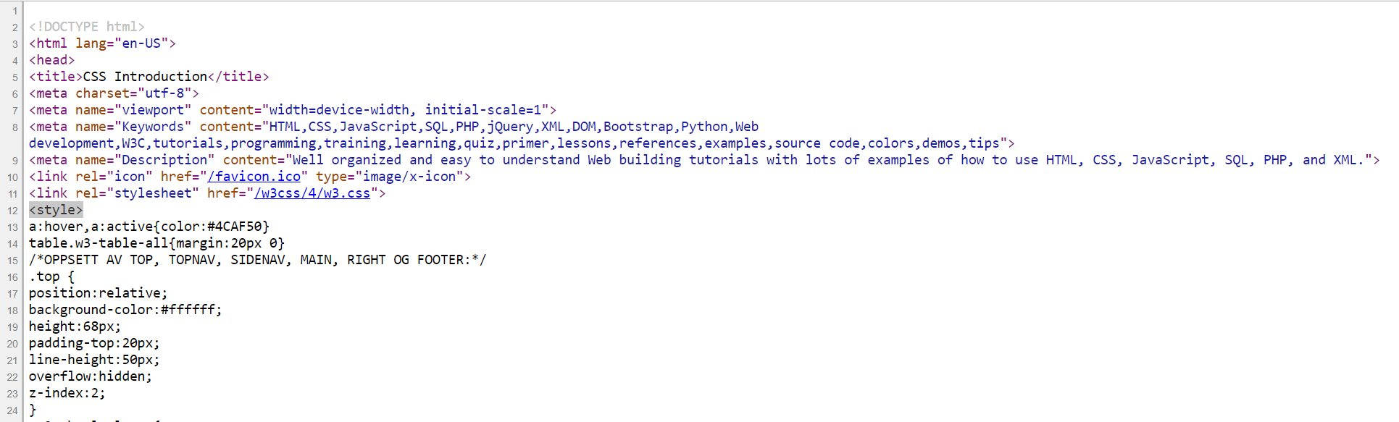

External style sheet:

Read the css file in the server!

CSS files are stored in a plain text format, which means you can open and edit them with any text editor. However, you should use web development programs, such as Dreamweaver and ColdFusion Builder, which provide more advanced features for editing CSS files.

Why Use CSS?

CSS is used to define styles for your web pages, including the design, layout and variations in display for different devices and screen sizes.

CSS Solved a Big Problem

HTML was NEVER intended to contain tags for formatting a web page!

HTML was created to describe the content of a web page, like:

<h1>This is a heading</h1>

<p>This is a paragraph.</p>

When tags like <font>, and color attributes were added to the HTML 3.2 specification, it started a nightmare for web developers. Development of large websites, where fonts and color information were added to every single page, became a long and expensive process.

To solve this problem, the World Wide Web Consortium (W3C) created CSS.

CSS removed the style formatting from the HTML page!

CSS Saves a Lot of Work!

The style definitions are normally saved in external .css files.

With an external stylesheet file, you can change the look of an entire website by changing just one file!

<div> is a block level element.

<span> is an inline element.

Sources: <https://www.w3schools.com/css/css_syntax.asp>

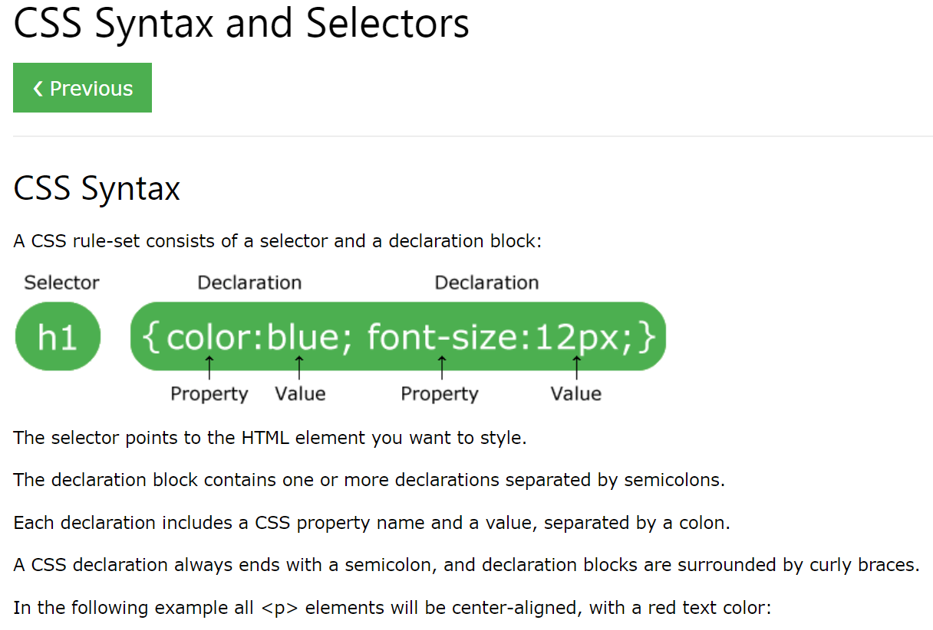

Sources: <https://www.w3schools.com/css/css_colors.asp>

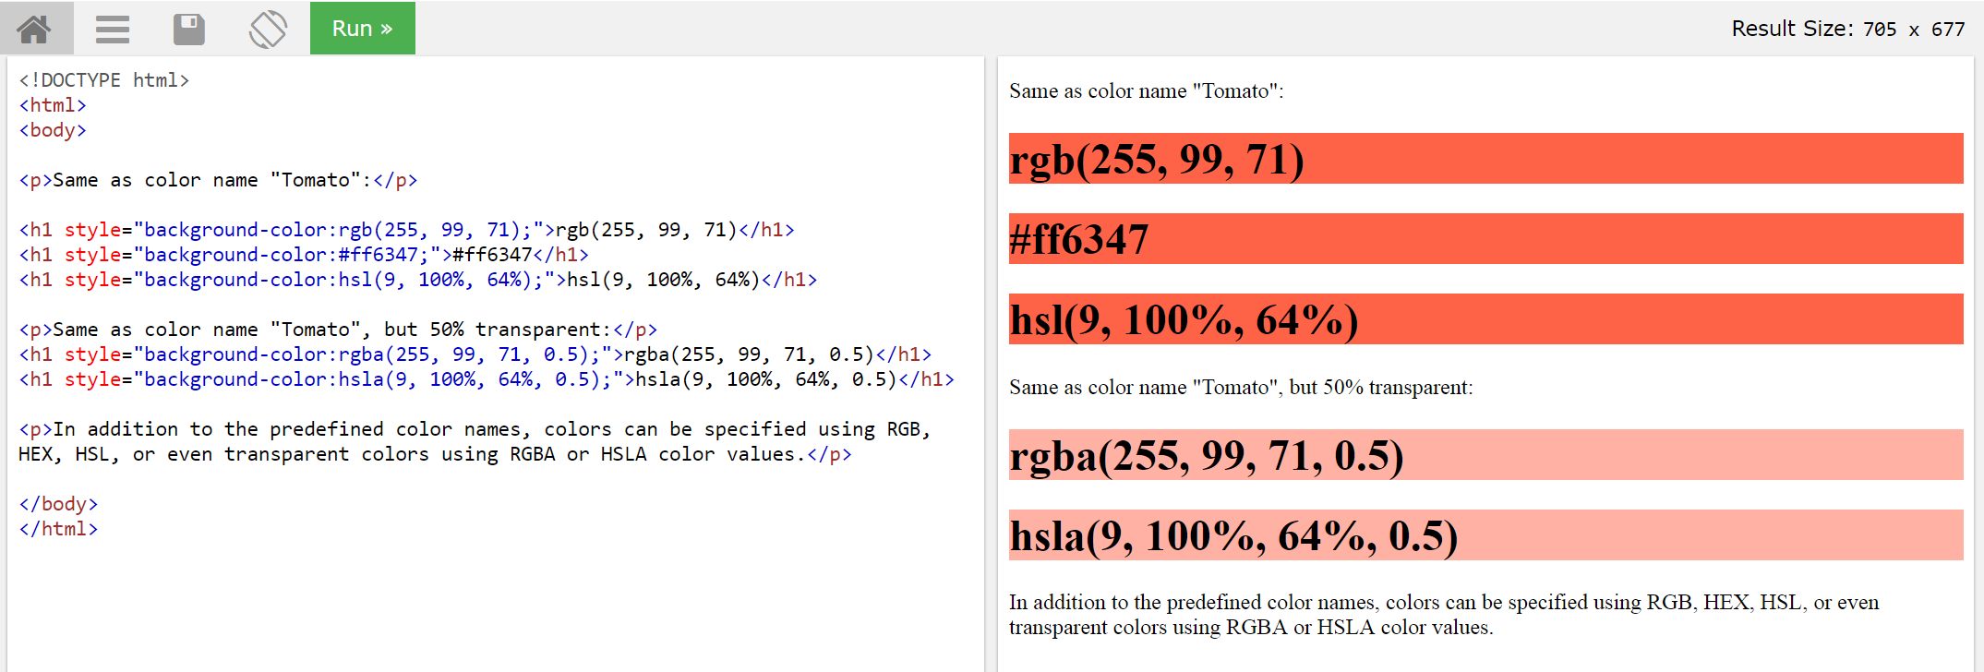

Sources: <https://www.w3schools.com/css/css_howto.asp>

Three Ways to Insert CSS

There are three ways of inserting a style sheet:

1) External style sheet

2) Embedded style sheet/Internal style sheet

3) Inline style

***(Which one is better?)***

**1) External Style Sheet:**

With an external style sheet, you can change the look of an entire website by changing just one file!

Each page must include a reference to the external style sheet file inside the <link> element. The <link> element goes inside the <head> section:

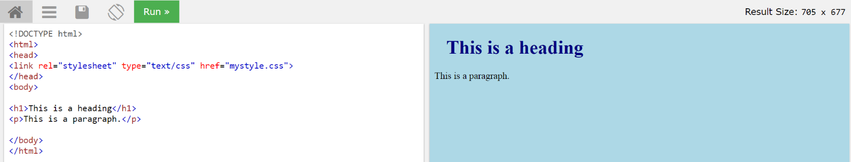

An external style sheet can be written in any text editor. The file should not contain any html tags. The style sheet file must be saved with a .css extension.

**2.1) Embedded style sheet/Internal Style Sheet:**

An internal style sheet may be used if one single page has a unique style.

Internal styles are defined within the <style> element, inside the <head> section of an HTML page:

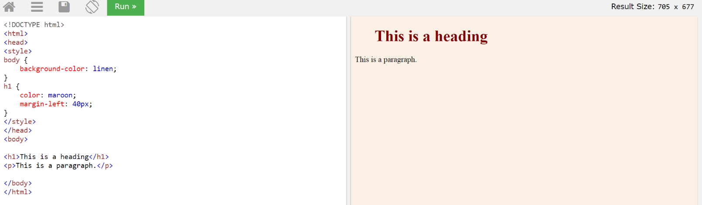

**2.2) Embedded style sheet/Internal Style Sheet:** <https://www.w3schools.com/html/tryit.asp?filename=tryhtml_css_internal>

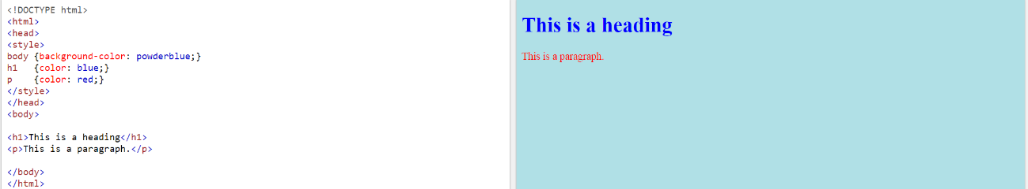

Sources: <https://www.w3schools.com/css/tryit.asp?filename=trycss_dropdown_button>

***Question!!!!!! Compare external style sheet (P.19) with embedded style, which one is better?***

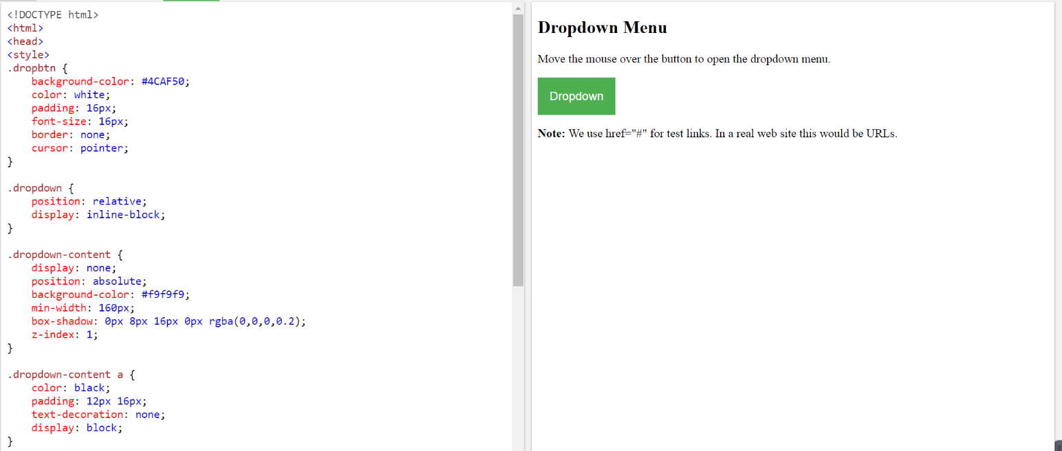

**3) Inline Styles:**

An inline style may be used to apply a unique style for a single element.

To use inline styles, add the style attribute to the relevant element. The style attribute can contain any CSS property.

The example below shows how to change the color and the left margin of a <h1> element:

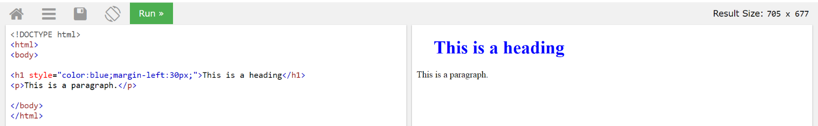

<End of CSS examples>

Example of inheritance:

No color define

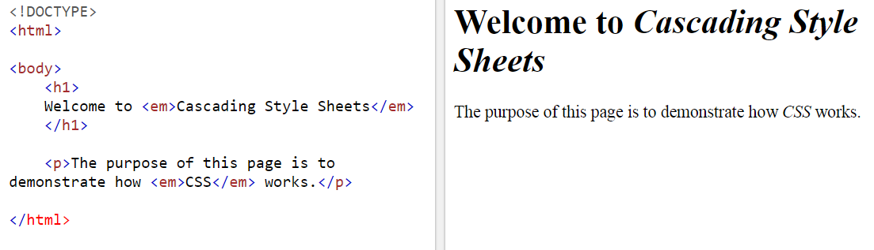

Define the color in each sentence (Inline CSS)

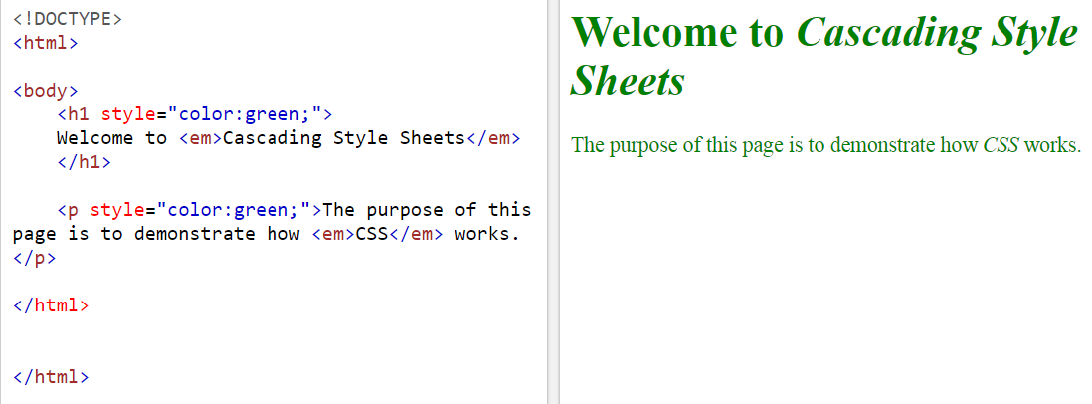

Define h1 in the style (Embedded CSS)

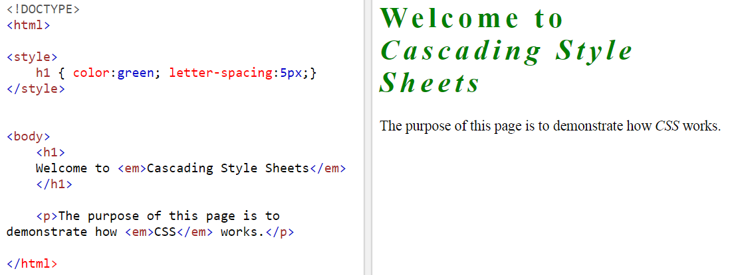

Define h1 and p in the style (Embedded CSS)

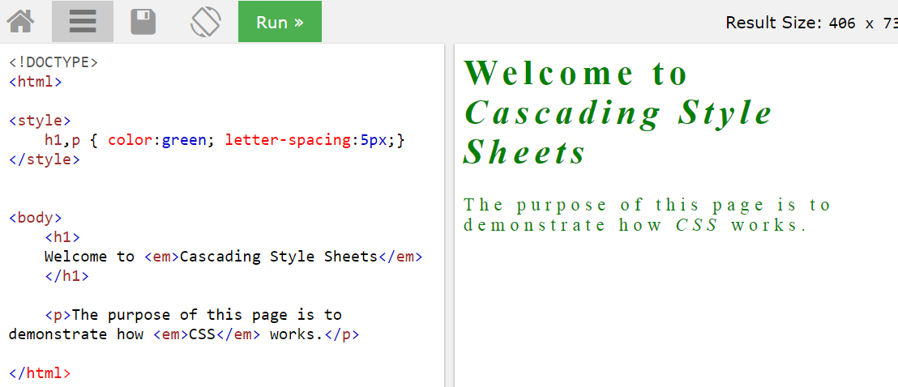

Example of Descendant Selectors 1:

<html>

<style>

p em{

color:red;

}

</style>

<body>

<h1>

Welcome to <em>Cascading Style Sheets</em>

</h1>

<p>

The purpose of this page is to demonstrate how <em>CSS</em> works.

</p>

</body>

</html>

Example of Descendant Selectors 2:

<html>

<style>

h1 em{

color:red;

}

</style>

<body>

<h1>

Welcome to <em>Cascading Style Sheets</em>

</h1>

<p>

The purpose of this page is to demonstrate how <em>CSS</em> works.

</p>

</body>

</html>

Example of Descendant Selectors 1:

Tips: define the style from <outside> to <inside> like outside <p> 🡪 inside <em>

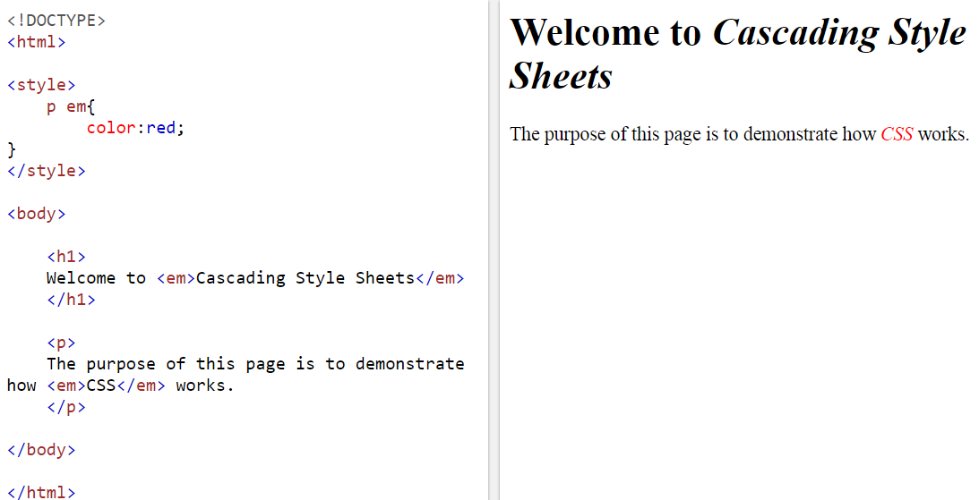

Example of Descendant Selectors 2:

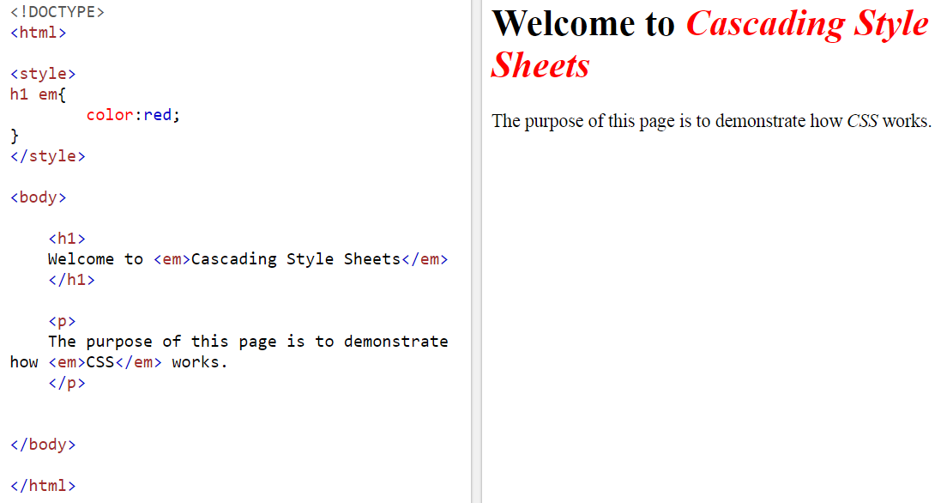

Example of Descendant selectors 3: <https://www.w3schools.com/css/tryit.asp?filename=trycss_sel_element_element>

outside<div> 🡪 inside <p>

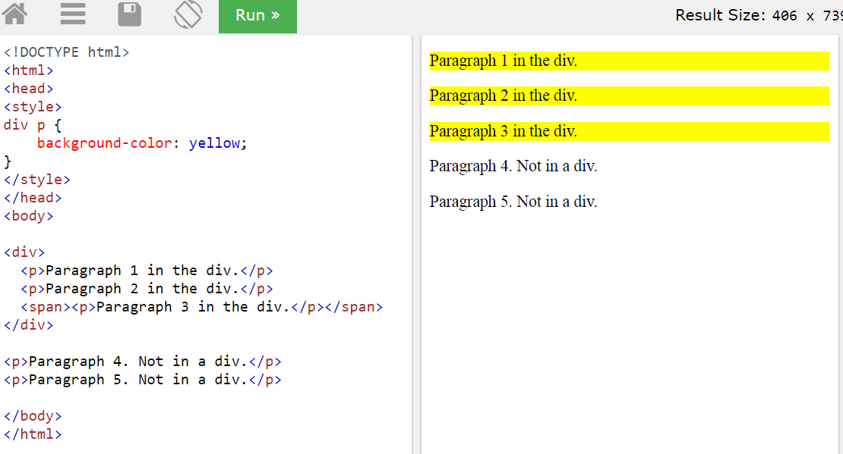

Example of CSS Combinators: <https://www.w3schools.com/css/css_combinators.asp>

There are four different combinators in CSS:

* descendant selector (space) [select the objects inside the sentence!]
* child selector (>)
* adjacent sibling selector (+)
* general sibling selector (~)

Example of child selector (>):

<https://www.w3schools.com/css/tryit.asp?filename=trycss_sel_element_gt>

The child selector selects all elements that are the immediate children of a specified element.

The following example selects all <p> elements that are immediate children of a <div> element:

🡪“di > p” specified the sentence with <p> in <div> only, not include <span> <p>.

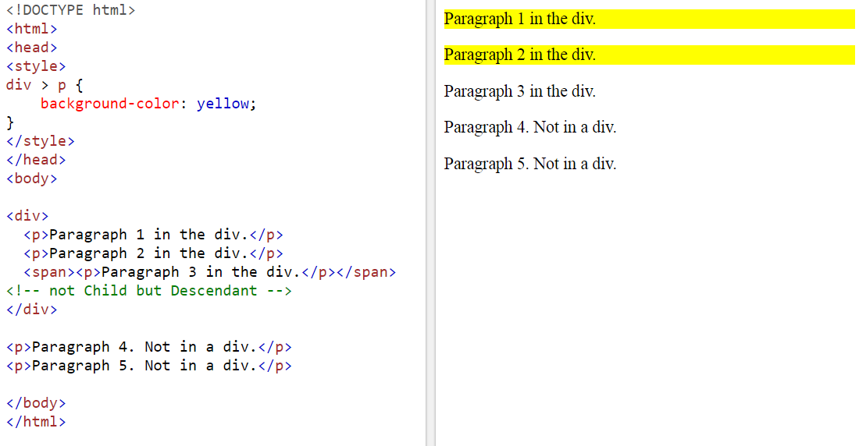

Example of adjacent sibling selector (+):

<https://www.w3schools.com/css/tryit.asp?filename=trycss_sel_element_pluss>

The adjacent sibling selector selects all elements that are the adjacent siblings of a specified element.

Sibling elements must have the same parent element, and "adjacent" means "immediately following".

The following example selects all <p> elements that are placed immediately after <div> elements:

* specify the background color of the following sentence after </div> (e.g. the next row only).

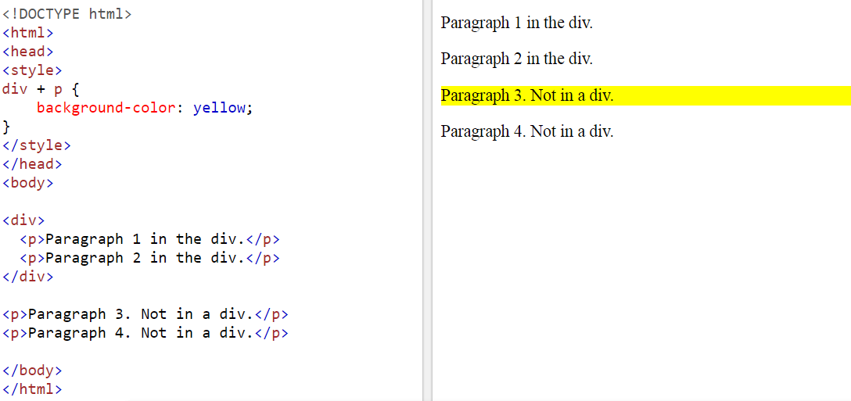

Example of general sibling selector (~):

<https://www.w3schools.com/css/tryit.asp?filename=trycss_sel_element_tilde>

The general sibling selector selects all elements that are siblings of a specified element.

The following example selects all <p> elements that are siblings of <div> elements:

* specify the background color of the sentence after </div> (e.g. the following sentences[exclusive])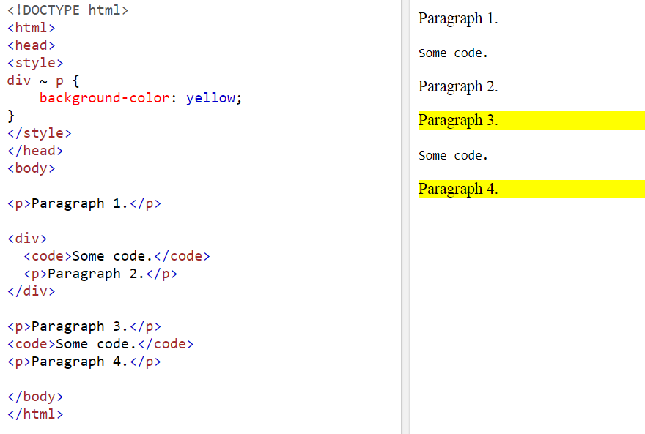

Example Psuedo-Elements:

<https://www.w3schools.com/css/css_pseudo_elements.asp>

p:first-line

p:first-letter{

font-size:24pt;

color:red;

}

<https://www.w3schools.com/css/tryit.asp?filename=trycss_firstline>

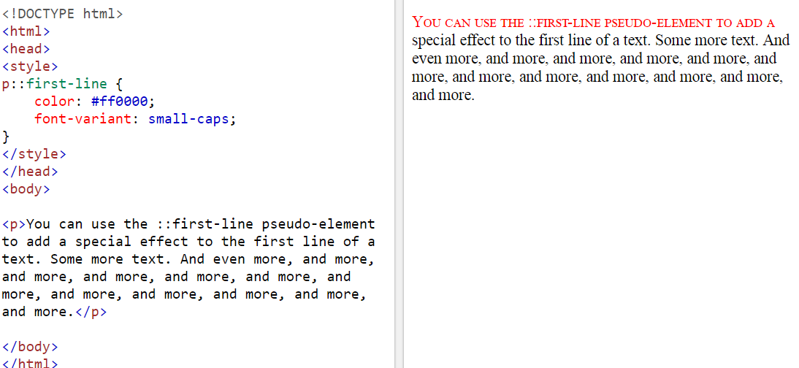

Example of Selectors – The *Class* Selector 1:

p.negative = specify the sentence with specific class <negative> (noted that negative is a label, you can call it positive or whatever!)

<p class=”positive”> …….. </p>

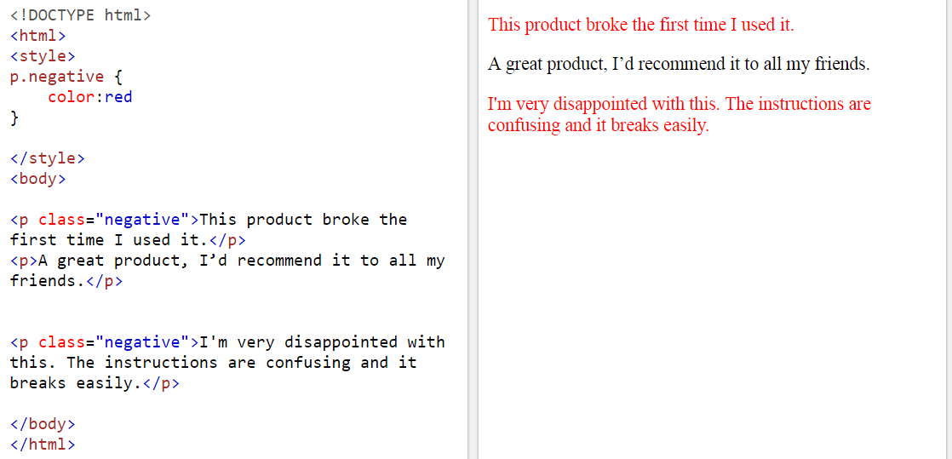

Example of Selectors – The *Class* Selector 2:

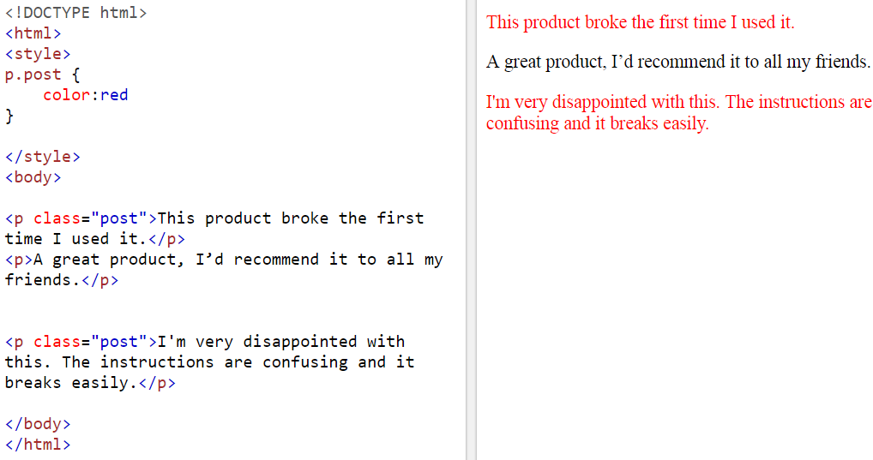

Example of The id Selector:

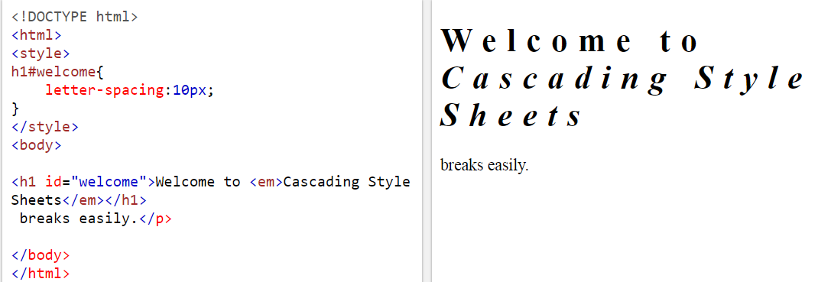

Example of Box Properties:

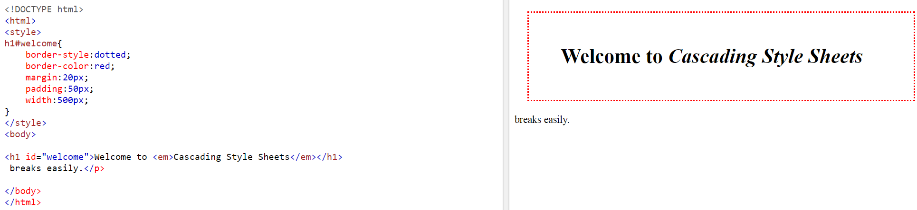

h1#welcome{

border-style:dotted;

border-color:red;

margin:20px;

padding:50px;

width:500px;

}

Example of Block and Inline Elements:

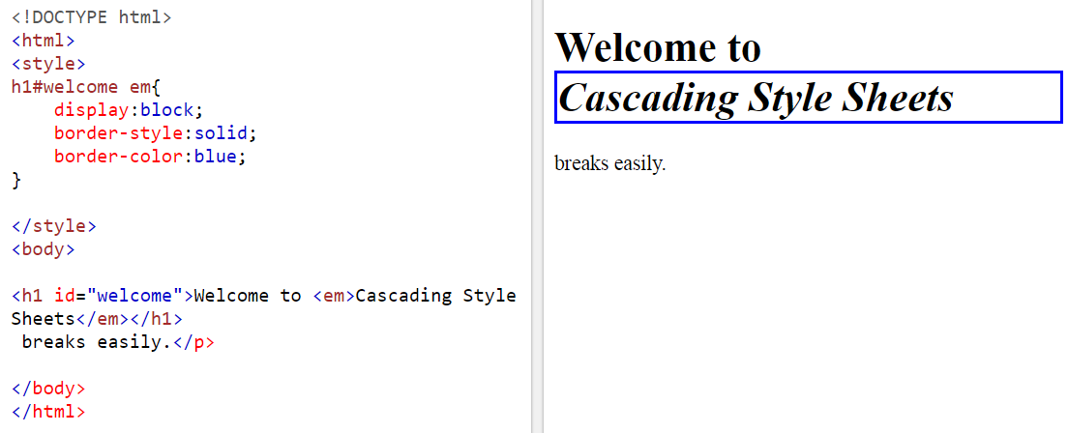

Examples of The <div> and <span> Elements:

<https://www.w3schools.com/tags/tryit.asp?filename=tryhtml_div_test>

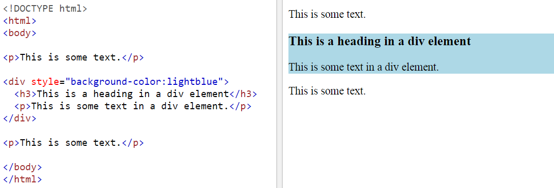

Example of other websites (see how people use <div>)

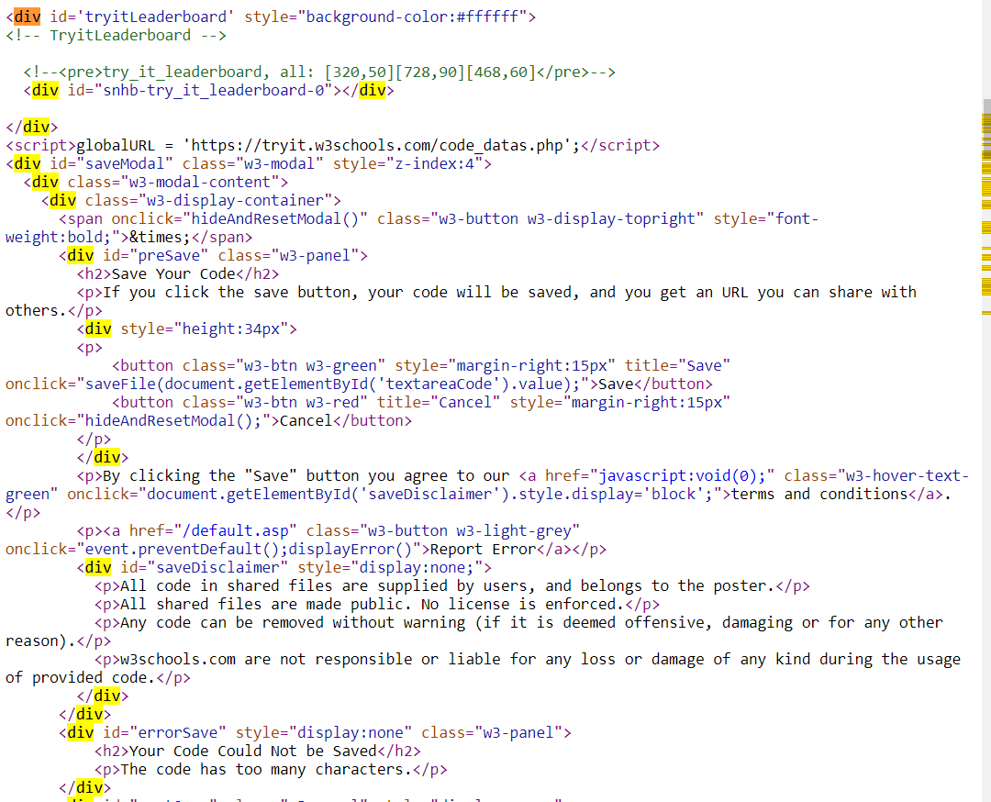

Sources: <https://getbootstrap.com/>

<https://stackpath.bootstrapcdn.com/bootstrap/4.1.3/css/bootstrap.min.css>

Build responsive, mobile-first projects on the web with the world's most popular front-end component library.

Bootstrap is an open source toolkit for developing with HTML, CSS, and JS. Quickly prototype your ideas or build your entire app with our Sass variables and mixins, responsive grid system, extensive prebuilt components, and powerful plugins built on jQuery.

***Get started!!! Copy-paste the stylesheet <link> into your <head> before all other stylesheets to load our CSS.***

Sources: <https://getbootstrap.com/docs/4.1/getting-started/introduction/>

<head>

<link rel="stylesheet" href="https://stackpath.bootstrapcdn.com/bootstrap/4.1.3/css/bootstrap.min.css" integrity="sha384-MCw98/SFnGE8fJT3GXwEOngsV7Zt27NXFoaoApmYm81iuXoPkFOJwJ8ERdknLPMO" crossorigin="anonymous">

<script src="https://code.jquery.com/jquery-3.3.1.slim.min.js" integrity="sha384-q8i/X+965DzO0rT7abK41JStQIAqVgRVzpbzo5smXKp4YfRvH+8abtTE1Pi6jizo" crossorigin="anonymous"></script>

<script src="https://cdnjs.cloudflare.com/ajax/libs/popper.js/1.14.3/umd/popper.min.js" integrity="sha384-ZMP7rVo3mIykV+2+9J3UJ46jBk0WLaUAdn689aCwoqbBJiSnjAK/l8WvCWPIPm49" crossorigin="anonymous"></script>

<script src="https://stackpath.bootstrapcdn.com/bootstrap/4.1.3/js/bootstrap.min.js" integrity="sha384-ChfqqxuZUCnJSK3+MXmPNIyE6ZbWh2IMqE241rYiqJxyMiZ6OW/JmZQ5stwEULTy" crossorigin="anonymous"></script>

</head>

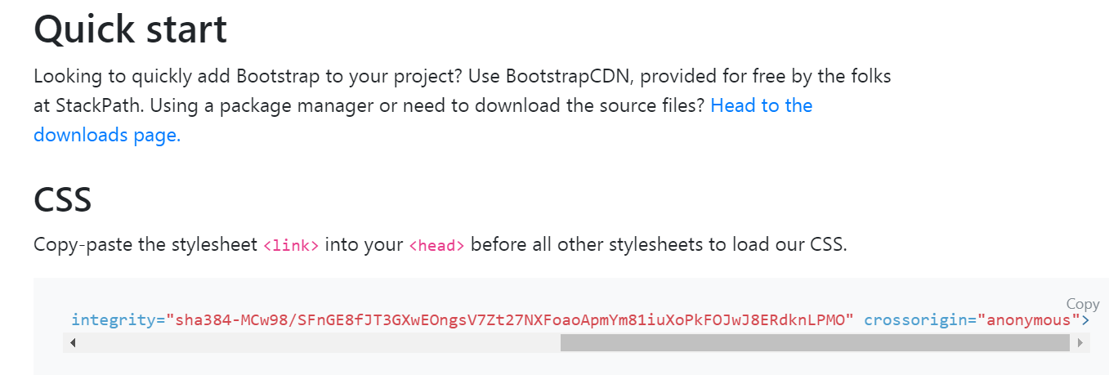

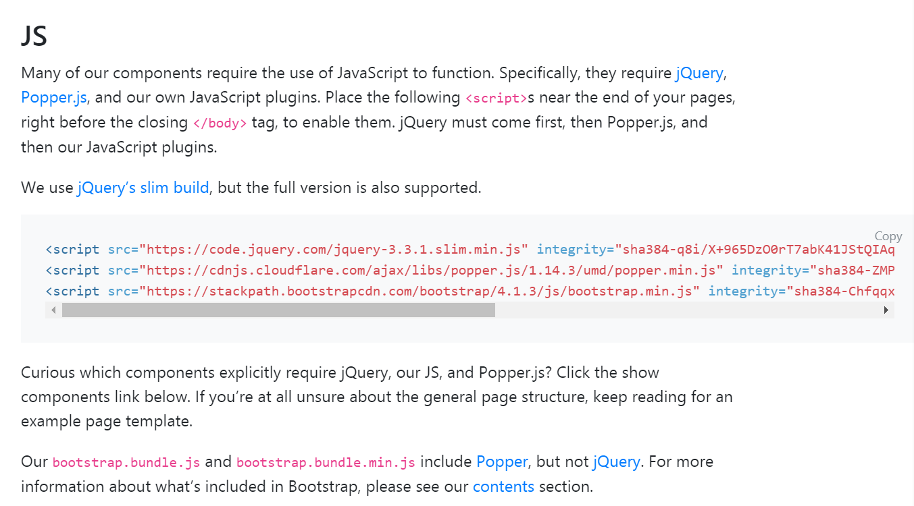

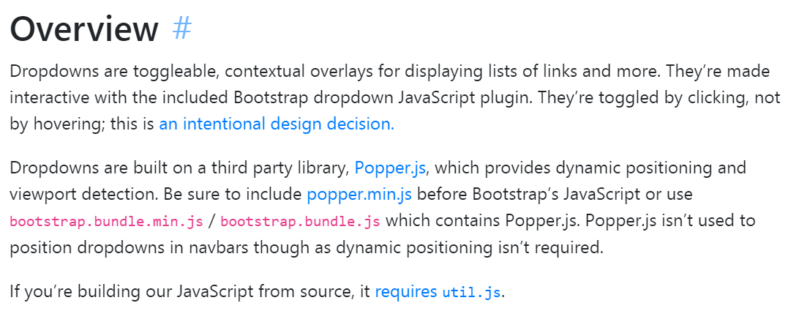

Sources of buttons: <https://getbootstrap.com/docs/4.1/components/buttons/>

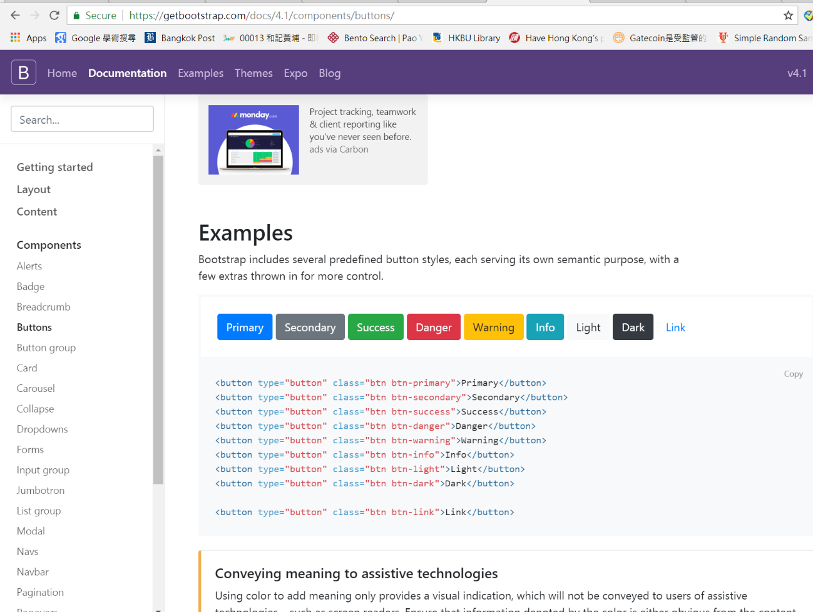

Example of buttons 1: <https://www.w3schools.com/html/tryit.asp?filename=tryhtml_default>

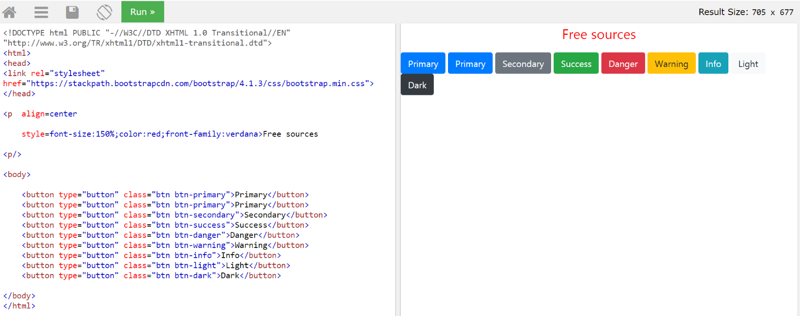

Example of buttons:

<!DOCTYPE html PUBLIC "-//W3C//DTD XHTML 1.0 Transitional//EN" "http://www.w3.org/TR/xhtml1/DTD/xhtml1-transitional.dtd">

<html>

<head>

<link rel="stylesheet" href="https://stackpath.bootstrapcdn.com/bootstrap/4.1.3/css/bootstrap.min.css">

</head>

<p align=center

style=font-size:150%;color:red;front-family:verdana>Free sources

<p/>

<body>

<button type="button" class="btn btn-primary">Primary</button>

<button type="button" class="btn btn-primary">Primary</button>

<button type="button" class="btn btn-secondary">Secondary</button>

<button type="button" class="btn btn-success">Success</button>

<button type="button" class="btn btn-danger">Danger</button>

<button type="button" class="btn btn-warning">Warning</button>

<button type="button" class="btn btn-info">Info</button>

<button type="button" class="btn btn-light">Light</button>

<button type="button" class="btn btn-dark">Dark</button>

</body>

</html>

Example of buttons 2:

<https://getbootstrap.com/docs/4.1/components/dropdowns/>

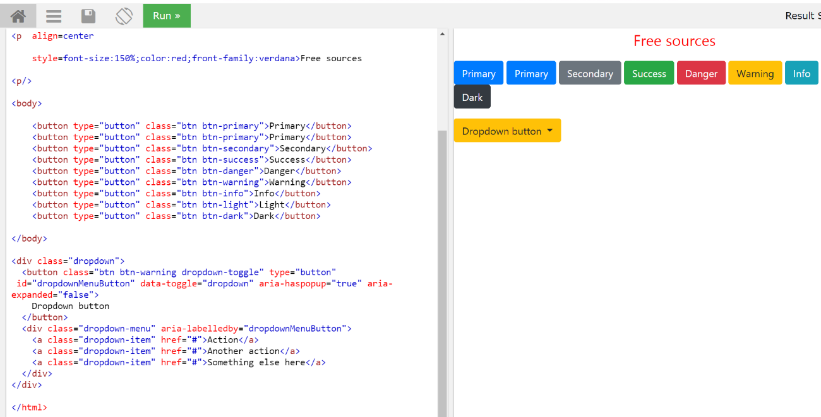

Example of buttons 2:

<!DOCTYPE html PUBLIC "-//W3C//DTD XHTML 1.0 Transitional//EN" "http://www.w3.org/TR/xhtml1/DTD/xhtml1-transitional.dtd">

<html>

<head>

<link rel="stylesheet" href="https://stackpath.bootstrapcdn.com/bootstrap/4.1.3/css/bootstrap.min.css" integrity="sha384-MCw98/SFnGE8fJT3GXwEOngsV7Zt27NXFoaoApmYm81iuXoPkFOJwJ8ERdknLPMO" crossorigin="anonymous">

<script src="https://code.jquery.com/jquery-3.3.1.slim.min.js" integrity="sha384-q8i/X+965DzO0rT7abK41JStQIAqVgRVzpbzo5smXKp4YfRvH+8abtTE1Pi6jizo" crossorigin="anonymous"></script>

<script src="https://cdnjs.cloudflare.com/ajax/libs/popper.js/1.14.3/umd/popper.min.js" integrity="sha384-ZMP7rVo3mIykV+2+9J3UJ46jBk0WLaUAdn689aCwoqbBJiSnjAK/l8WvCWPIPm49" crossorigin="anonymous"></script>

<script src="https://stackpath.bootstrapcdn.com/bootstrap/4.1.3/js/bootstrap.min.js" integrity="sha384-ChfqqxuZUCnJSK3+MXmPNIyE6ZbWh2IMqE241rYiqJxyMiZ6OW/JmZQ5stwEULTy" crossorigin="anonymous"></script>

<p align=center

style=font-size:150%;color:red;front-family:verdana>Free sources

<p/>

<body>

<button type="button" class="btn btn-primary">Primary</button>

<button type="button" class="btn btn-primary">Primary</button>

<button type="button" class="btn btn-secondary">Secondary</button>

<button type="button" class="btn btn-success">Success</button>

<button type="button" class="btn btn-danger">Danger</button>

<button type="button" class="btn btn-warning">Warning</button>

<button type="button" class="btn btn-info">Info</button>

<button type="button" class="btn btn-light">Light</button>

<button type="button" class="btn btn-dark">Dark</button>

</body>

<div class="dropdown">

<button class="btn btn-warning dropdown-toggle" type="button" id="dropdownMenuButton" data-toggle="dropdown" aria-haspopup="true" aria-expanded="false">

Dropdown button

</button>

<div class="dropdown-menu" aria-labelledby="dropdownMenuButton">

<a class="dropdown-item" href="#">Action</a>

<a class="dropdown-item" href="#">Another action</a>

<a class="dropdown-item" href="#">Something else here</a>

</div>

</div>

</html>

Example of external style sheet:

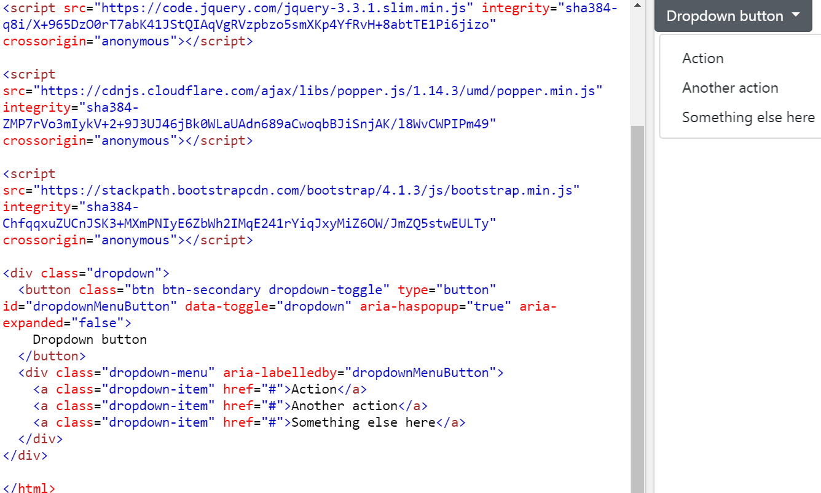

Example of external style sheet:

<!DOCTYPE html PUBLIC "-//W3C//DTD XHTML 1.0 Transitional//EN" "http://www.w3.org/TR/xhtml1/DTD/xhtml1-transitional.dtd">

<html>

<head>

<link rel="stylesheet" href="https://stackpath.bootstrapcdn.com/bootstrap/4.1.3/css/bootstrap.min.css" integrity="sha384-MCw98/SFnGE8fJT3GXwEOngsV7Zt27NXFoaoApmYm81iuXoPkFOJwJ8ERdknLPMO" crossorigin="anonymous">

<script src="https://code.jquery.com/jquery-3.3.1.slim.min.js" integrity="sha384-q8i/X+965DzO0rT7abK41JStQIAqVgRVzpbzo5smXKp4YfRvH+8abtTE1Pi6jizo" crossorigin="anonymous"></script>

<script src="https://cdnjs.cloudflare.com/ajax/libs/popper.js/1.14.3/umd/popper.min.js" integrity="sha384-ZMP7rVo3mIykV+2+9J3UJ46jBk0WLaUAdn689aCwoqbBJiSnjAK/l8WvCWPIPm49" crossorigin="anonymous"></script>

<script src="https://stackpath.bootstrapcdn.com/bootstrap/4.1.3/js/bootstrap.min.js" integrity="sha384-ChfqqxuZUCnJSK3+MXmPNIyE6ZbWh2IMqE241rYiqJxyMiZ6OW/JmZQ5stwEULTy" crossorigin="anonymous"></script>

<div class="dropdown">

<button class="btn btn-secondary dropdown-toggle" type="button" id="dropdownMenuButton" data-toggle="dropdown" aria-haspopup="true" aria-expanded="false">

Dropdown button

</button>

<div class="dropdown-menu" aria-labelledby="dropdownMenuButton">

<a class="dropdown-item" href="#">Action</a>

<a class="dropdown-item" href="#">Another action</a>

<a class="dropdown-item" href="#">Something else here</a>

</div>

</div>

</html>