Sources: <https://www.w3schools.com/php/php_install.asp>

Use a Web Host With PHP Support

If your server has activated support for PHP you do not need to do anything.

Just create some .php files, place them in your web directory, and the server will automatically parse them for you.

You do not need to compile anything or install any extra tools.

Because PHP is free, most web hosts offer PHP support.

## Set Up PHP on Your Own PC

However, if your server does not support PHP, you must:

* install a web server
* install PHP
* install a database, such as MySQL

The official PHP website (PHP.net) has installation instructions for PHP: <http://php.net/manual/en/install.php>

1)Concept of get and post in Chinese: <https://ithelp.ithome.com.tw/articles/10155801>

2)Concept of get and post in Chinese: <http://www.wibibi.com/info.php?tid=235>

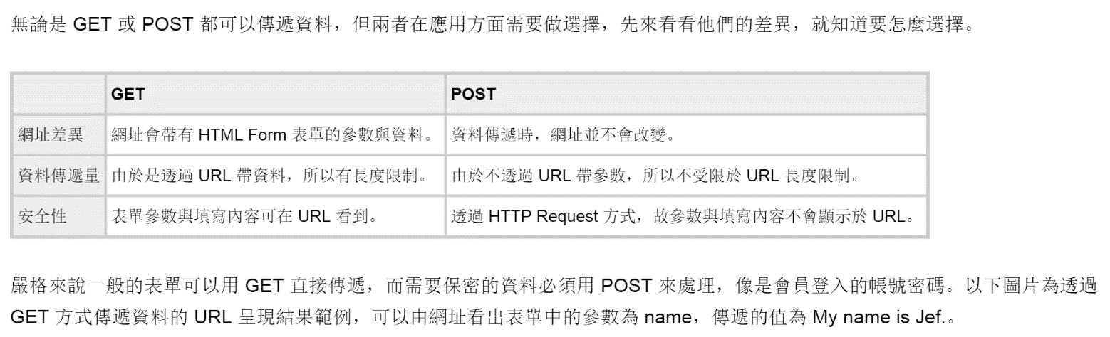

3)Concept of post in Chinese: <http://www.wibibi.com/info.php?tid=144>

This article will introduce the use of PHP POST in two parts. You need to prepare two files, the HTML form (test_form.html) and the PHP POST page (test_post.php).

4)Concept of get in Chinese: <http://www.wibibi.com/info.php?tid=145>

5)Concept of php random in Chinese: <http://www.wibibi.com/info.php?tid=PHP_rand_%E9%9A%A8%E6%A9%9F%E6%95%B4%E6%95%B8%E5%87%BD%E6%95%B8>

* Echo represents the meaning of the output,

## ** PHP echo and print Statements

echo and print are more or less the same. They are both used to output data to the screen.

The differences are small: echo has no return value while print has a return value of 1 so it can be used in expressions. echo can take multiple parameters (although such usage is rare) while print can take one argument. echo is marginally faster than print.