**HTML tables-L03**

Sources: <https://www.w3schools.com/html/html_tables.asp>

Chapter Summary

Use the HTML <table> element to define a table

Use the HTML <tr> element to define a table row

Use the HTML <td> element to define a table data

Use the HTML <th> element to define a table heading

Use the HTML <caption> element to define a table caption

Use the CSS border property to define a border

Use the CSS border-collapse property to collapse cell borders

Use the CSS padding property to add padding to cells

Use the CSS text-align property to align cell text

Use the CSS border-spacing property to set the spacing between cells

Use the colspan attribute to make a cell span many columns

Use the rowspan attribute to make a cell span many rows

Use the id attribute to uniquely define one table

Example 1: inside the table (save as “example1.html)

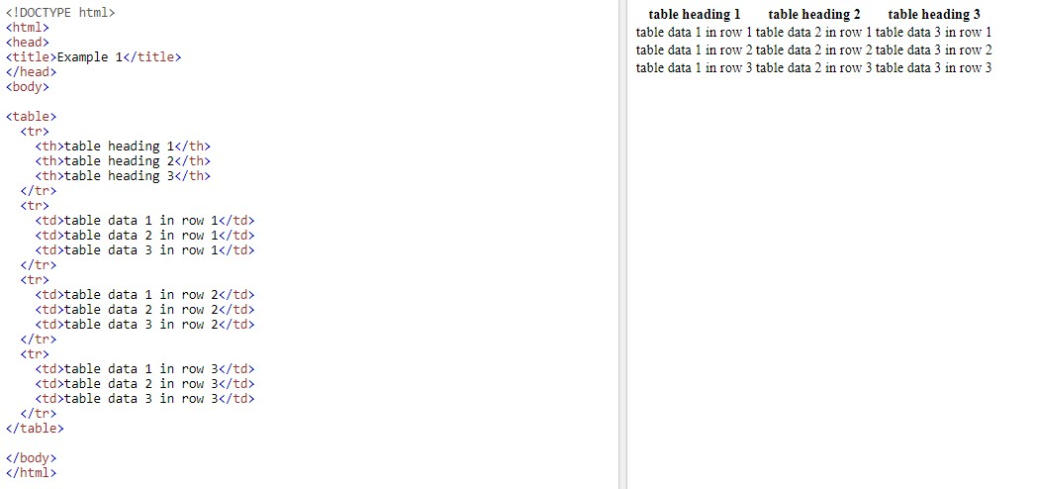

The format of a table:

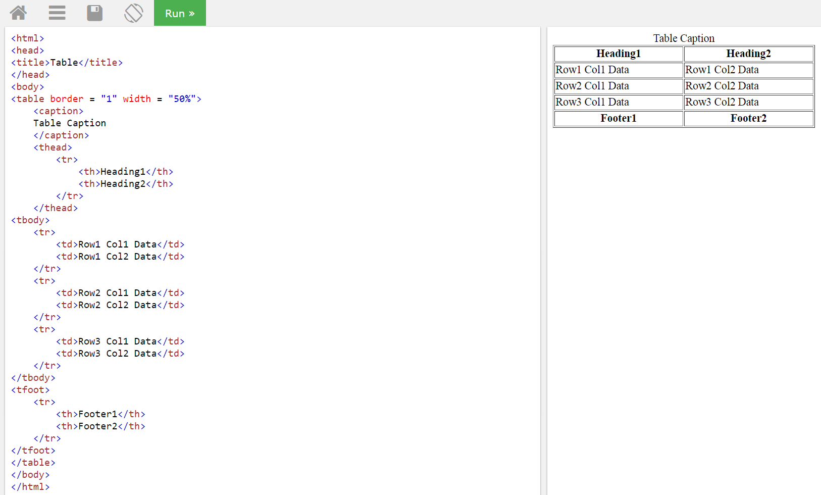

Example 2: the format of the table (save as “example2.html)

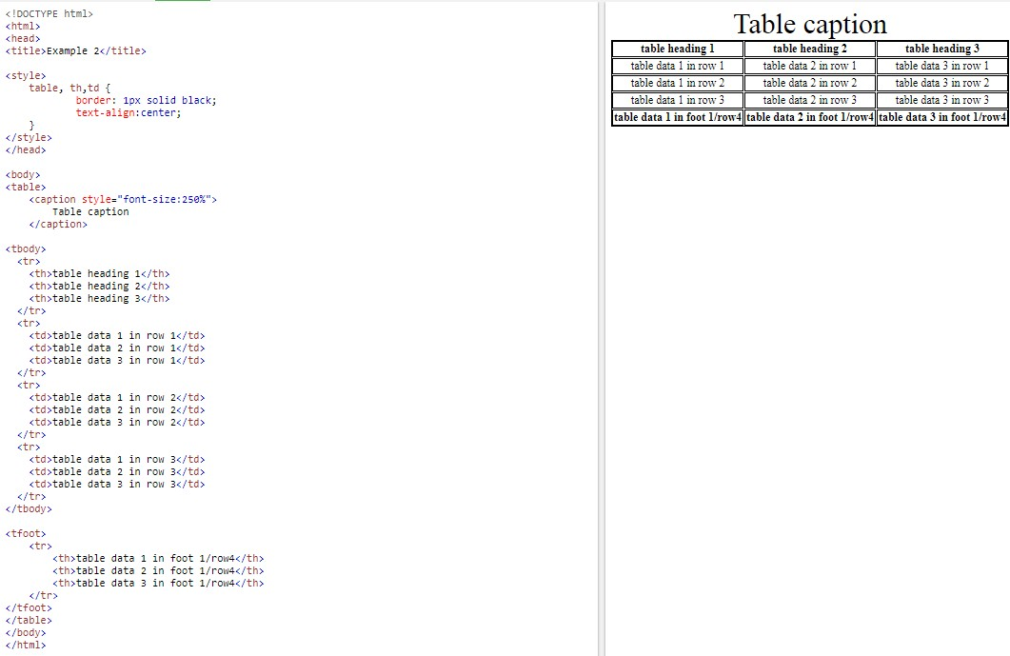

A table with styles:

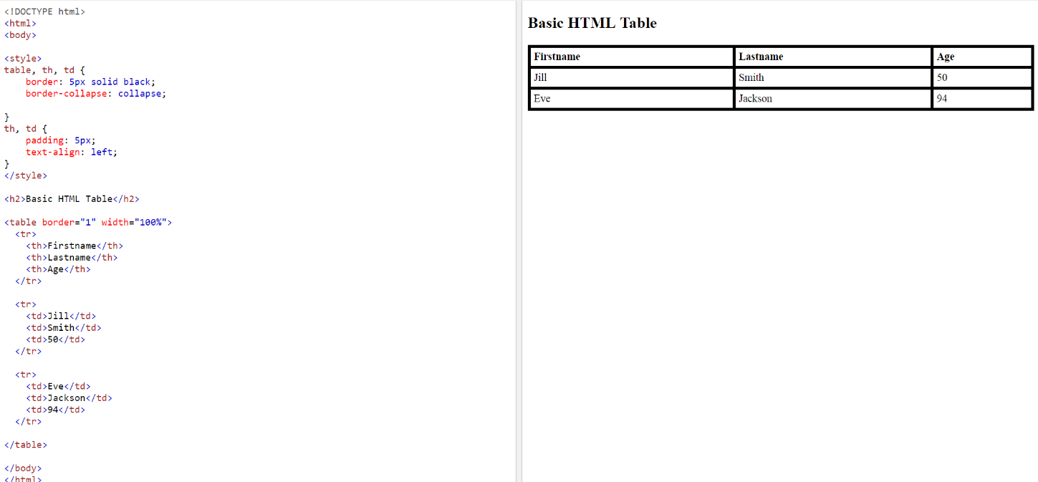

A table without styles:

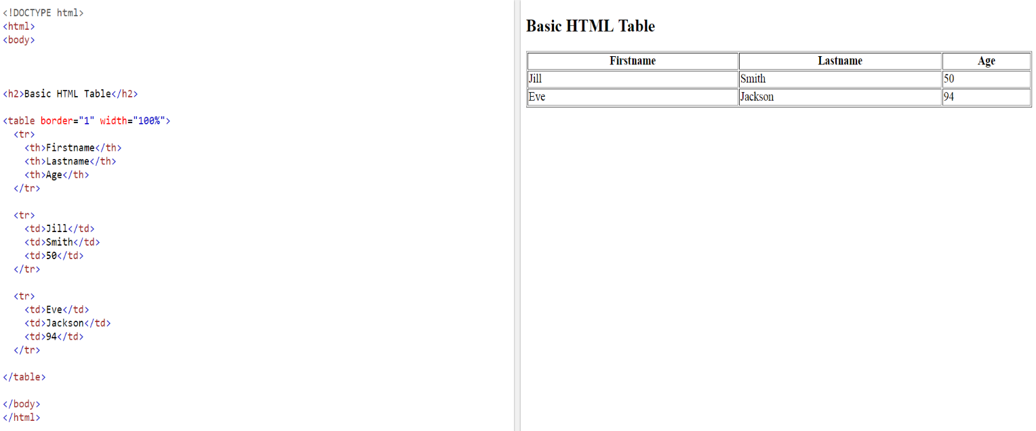

Example 3: style of the table (save as “example3.html)

Results of the HTML code:

<https://www.w3schools.com/html/tryit.asp?filename=tryhtml_table_id1>

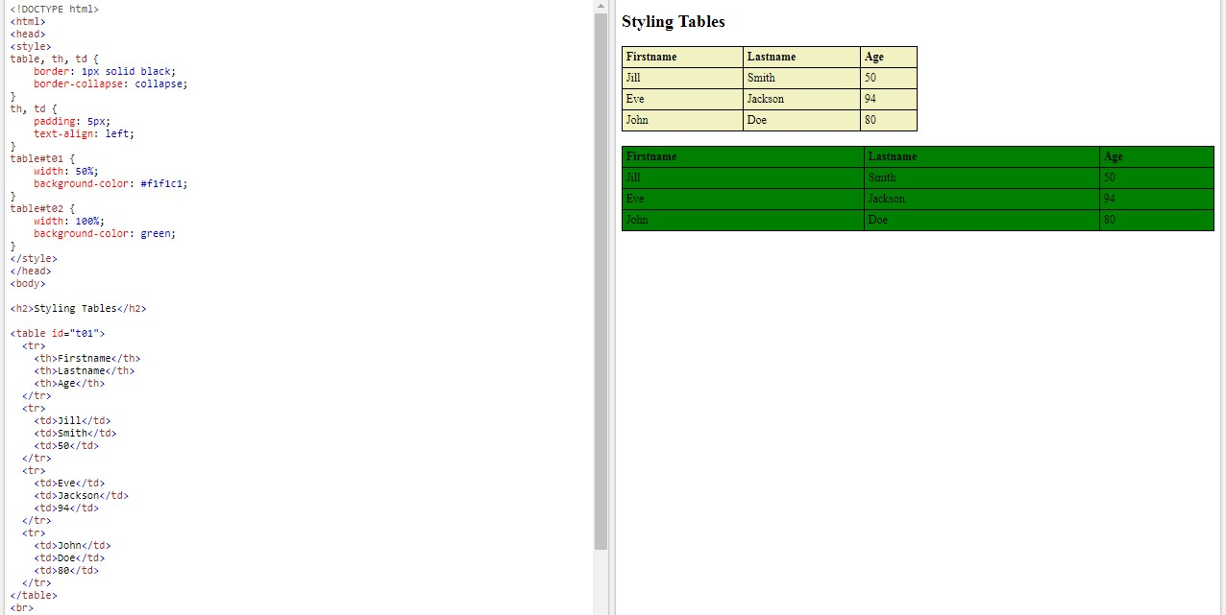

TBC-Example 3: style of the table (save as “example3.html)

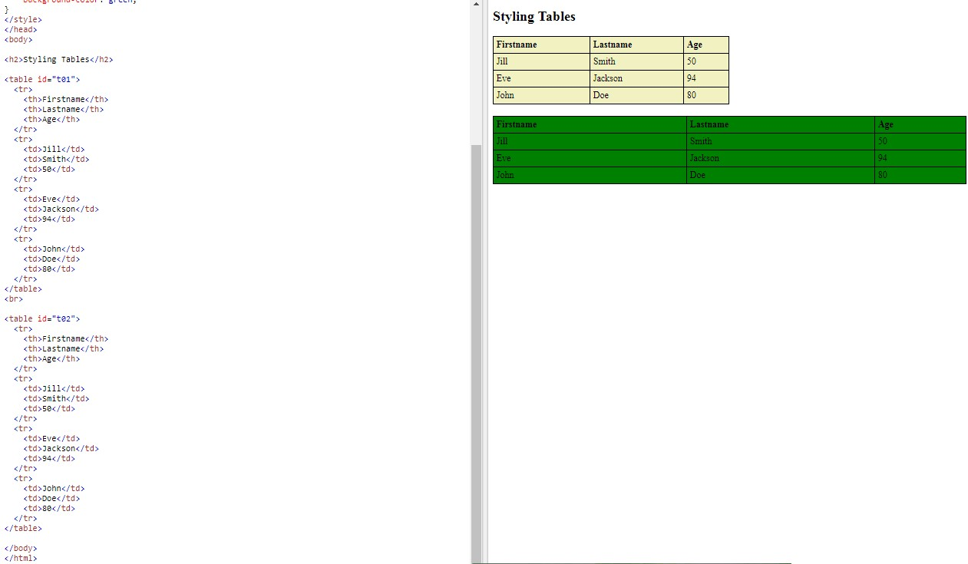

Conclusion or tips:

<head>

<style>

1. define the style of the table, table heading, table data

2. define the space and text-alignment for the table heading and table data

3. define the size and color of a table (please refer the ID to the table).

</style>

</head>

<body>

<table>

4. Assign an ID to the table

5. define the caption of the table.

6. define the heading of the table.

<tbody>

7. type the information inside the table.

</tbody>

8. Optional: type the foot of the table.

</table>

</body>

Example 4: Insert images into the table

Exercise 1

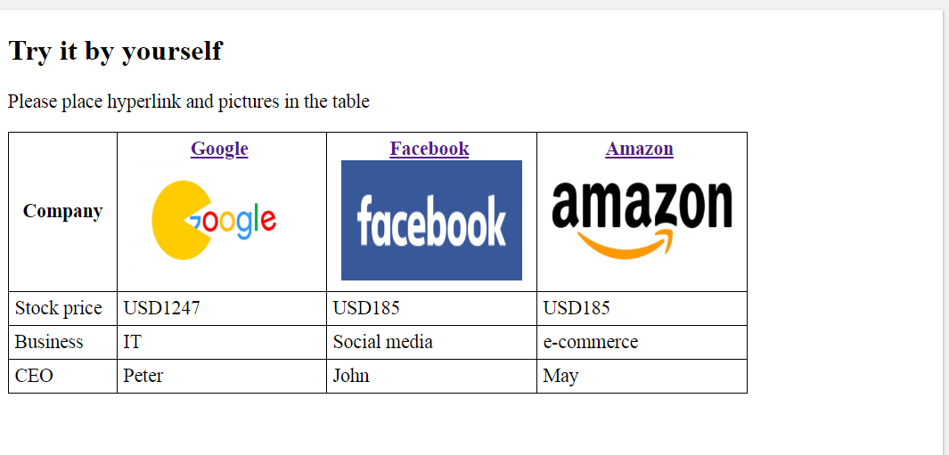

Exercise 2 (save as “example4.html)

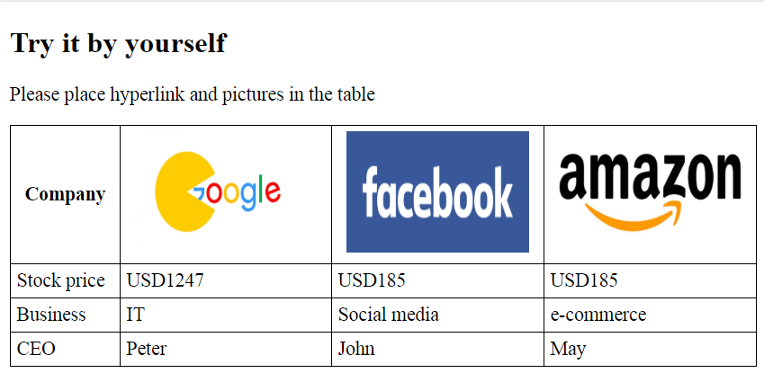

Example 5: Insert videos into the table (save as “example5.html)

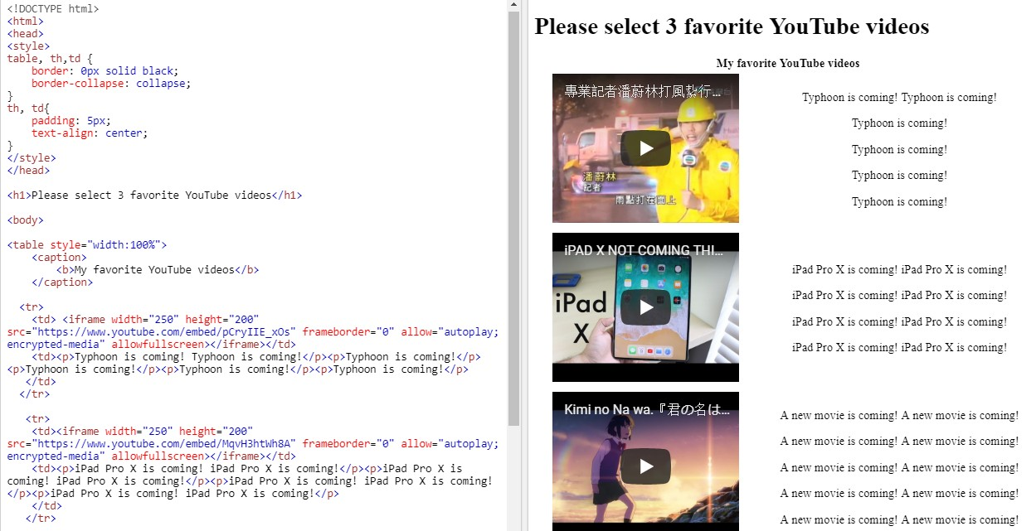

Example 6: Merge space/box in a table (save as “example6.html)

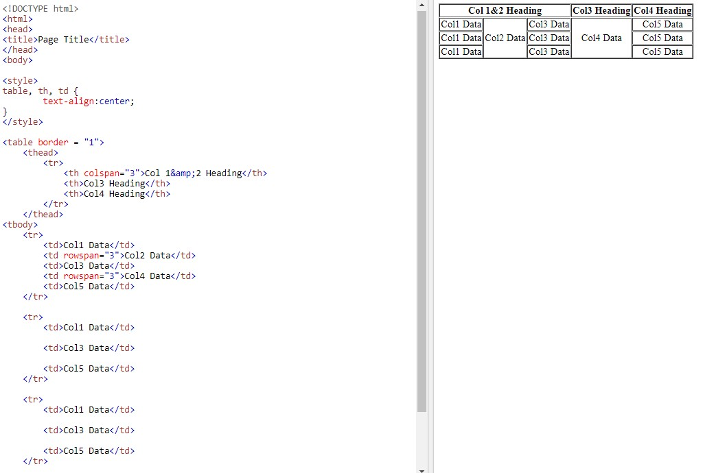

Example 7: Internal linking

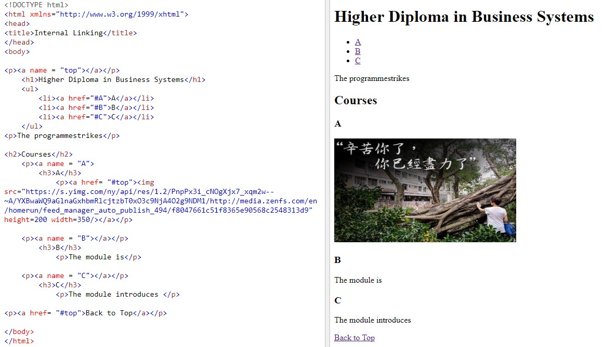

Sources: <https://www.w3schools.com/html/html_iframe.asp>

Tips for using iframe:

1.Save the html that you want to display in the frame in your local disk, for instance, Youtube.html.

2.Then type the following html code in a new html file "XXX.html" = “Youtube.html”.



<!DOCTYPE html>

<html>

<frameset cols="500,*">

<frame src="Youtube.html" />

<frame src="Social media.html" />

</frameset>

</html>

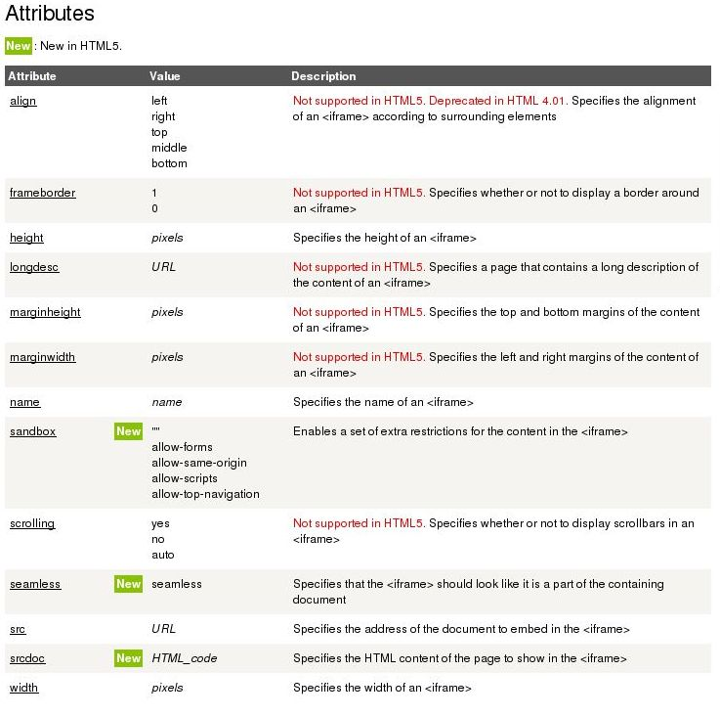

Example of all in once:

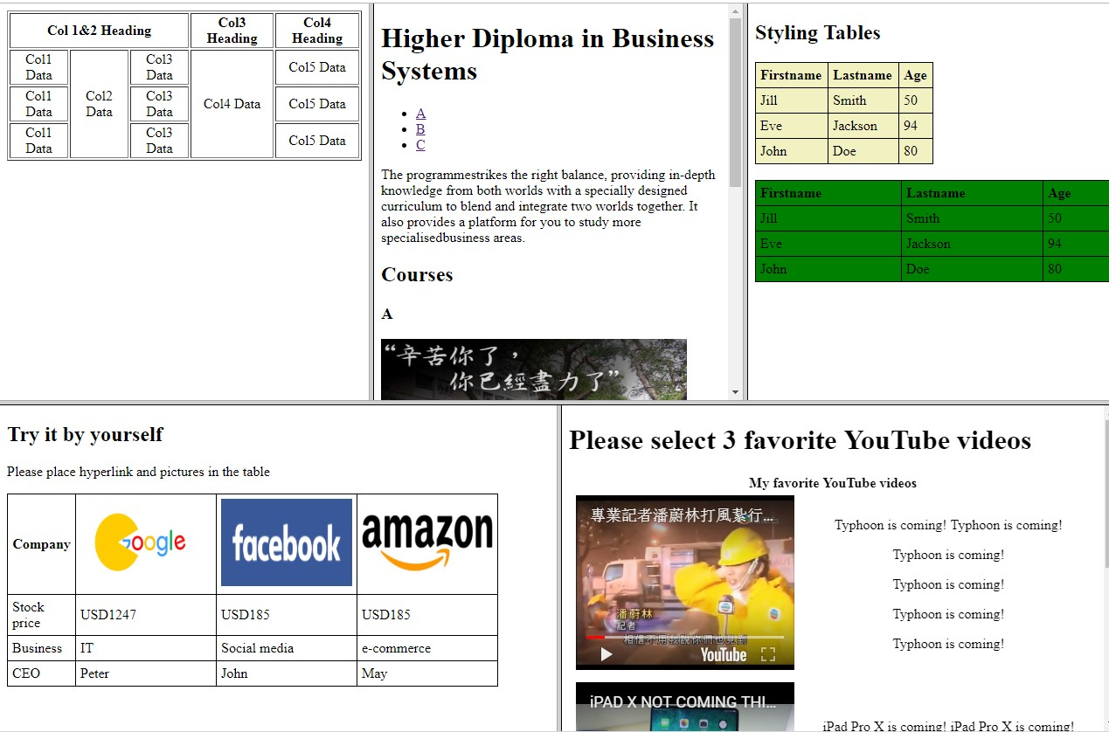

Sources: <https://www.w3schools.com/bootstrap/bootstrap_carousel.asp>

Example of Slideshow:



Example of all in once 2:

 