**Lecture 5-HTML Form Elements**

Sources: <https://www.w3schools.com/html/html_form_elements.asp>

Tag Description

<form> Defines an HTML form for user input

<input> Defines an input control

<textarea> Defines a multiline input control (text area)

<label> Defines a label for an <input> element

<fieldset> Groups related elements in a form

<legend> Defines a caption for a <fieldset> element

<select> Defines a drop-down list

<optgroup> Defines a group of related options in a drop-down list

<option> Defines an option in a drop-down list

<button> Defines a clickable button

<datalist> Specifies a list of pre-defined options for input controls

<output> Defines the result of a calculation

Type Description

<input type="text"> Defines a one-line text input field

<input type="radio"> Defines a radio button (for selecting one of many choices)

<input type="checkbox"> Defines a checkbox button (for selecting more than one choices)

<input type="submit"> Defines a submit button (for submitting the form)

The Name Attribute

Each input field must have a name attribute to be submitted.

If the name attribute is omitted, the data of that input field will not be sent at all.

This example will only submit the "Last name" input field:

Example of input text: <https://www.w3schools.com/html/tryit.asp?filename=tryhtml_form_submit>

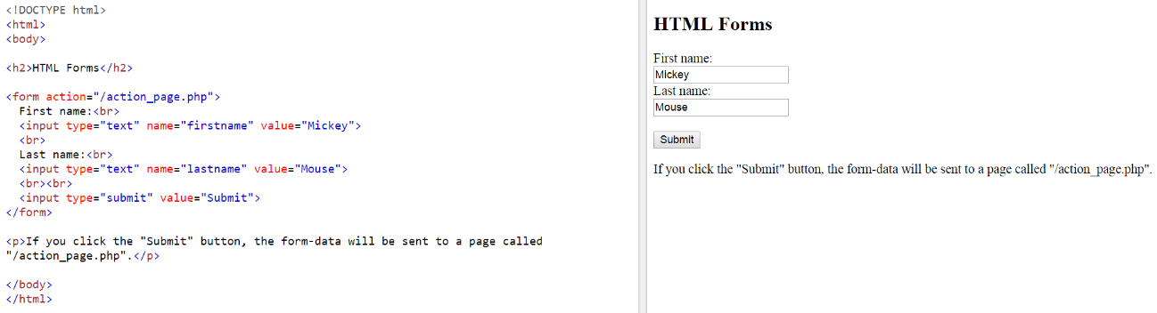

The Action Attribute

The action attribute defines the action to be performed when the form is submitted.

Normally, the form data is sent to a web page on the server when the user clicks on the submit button.

In the example above, the form data is sent to a page on the server called "/action_page.php". This page contains a server-side script that handles the form data:

🡪<form action="/action_page.php">

<form action="/action_page.php" method="get">

<form action="/action_page.php" method="post">

What is the difference between “get” and “post”? <https://www.w3schools.com/html/html_forms.asp>

When to Use GET?

The default method when submitting form data is GET.

However, when GET is used, the submitted form data will be visible in the page address field:

URL (e.g. /action_page.php?firstname=Mickey&lastname=Mouse)

Notes on GET:

Appends form-data into the URL in name/value pairs

The length of a URL is limited (about 3000 characters)

Never use GET to send sensitive data! (will be visible in the URL)

Useful for form submissions where a user wants to bookmark the result

GET is better for non-secure data, like query strings in Google

When to Use POST?

Always use POST if the form data contains sensitive or personal information. The POST method does not display the submitted form data in the page address field.

Notes on POST:

POST has no size limitations, and can be used to send large amounts of data.

Form submissions with POST cannot be bookmarked

Conclusion: get and post are the common method for submitting form data. We cannot determine which one is better because it depends on your situation. For example, for submitting ***non-sensitive data***, we use ***get*** method. For submitting ***sensitive*** data like password, we use ***post*** method.

Example of size attributes: <https://www.w3schools.com/html/tryit.asp?filename=tryhtml_input_attributes_size>

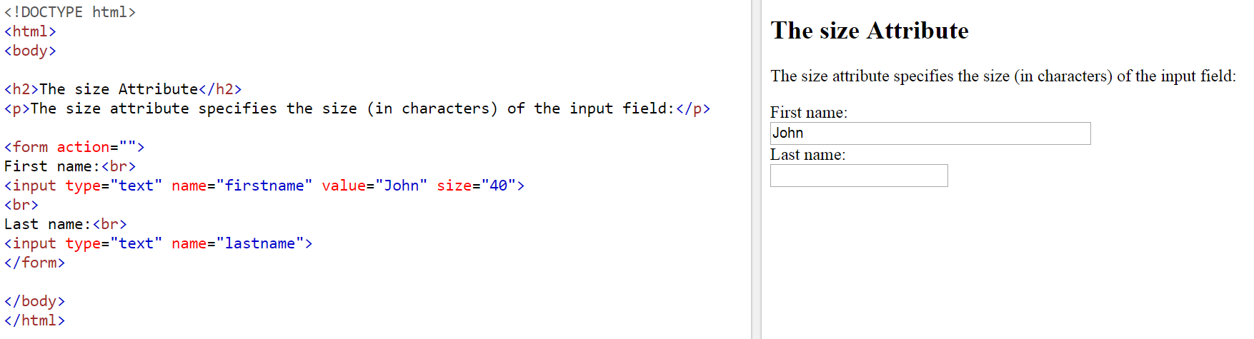

Example of Max length attributes: <https://www.w3schools.com/html/tryit.asp?filename=tryhtml_input_attributes_maxlength>

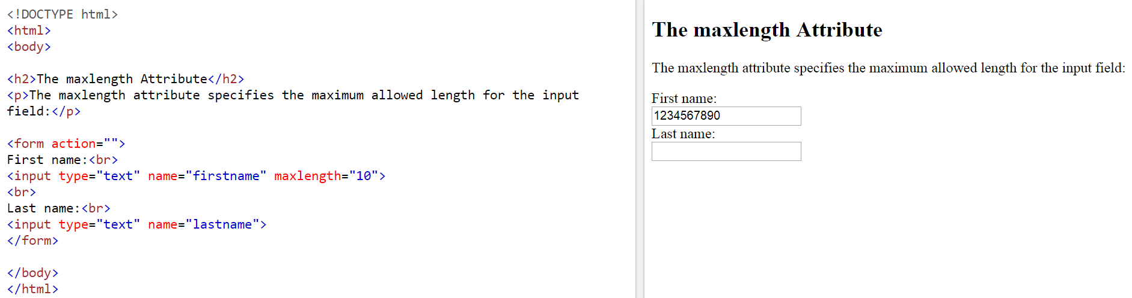

Example of auto-complete attribute: <https://www.w3schools.com/html/tryit.asp?filename=tryhtml5_input_autocomplete>

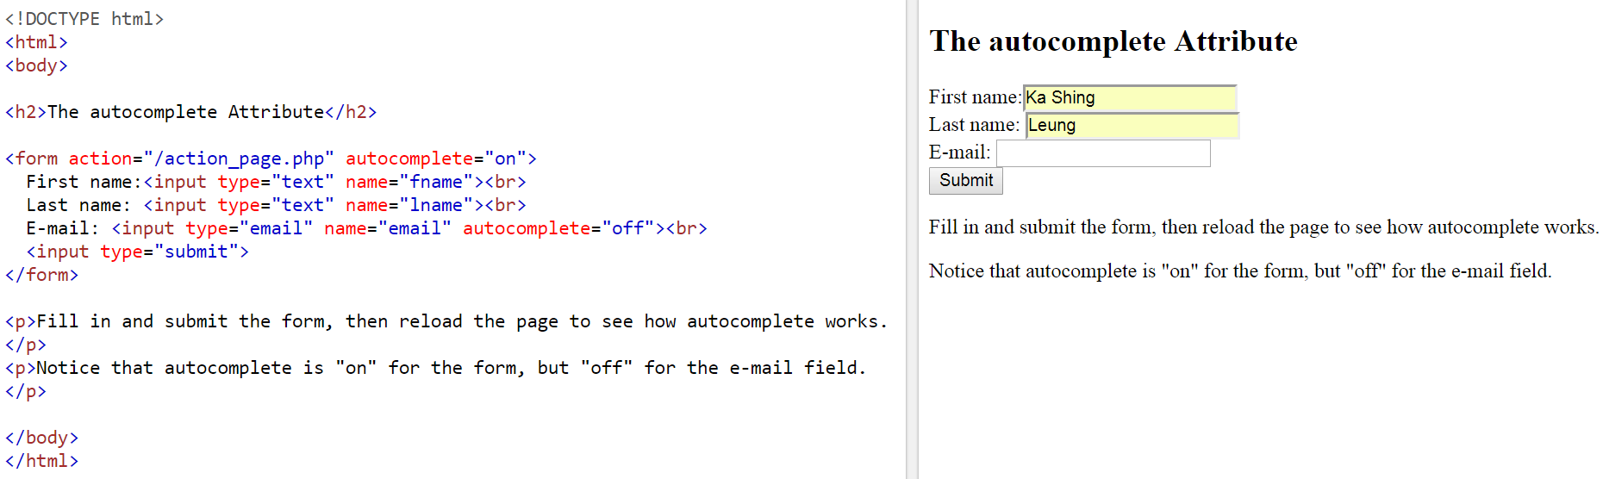

Example of Place holder attribute: <https://www.w3schools.com/html/tryit.asp?filename=tryhtml5_input_placeholder>

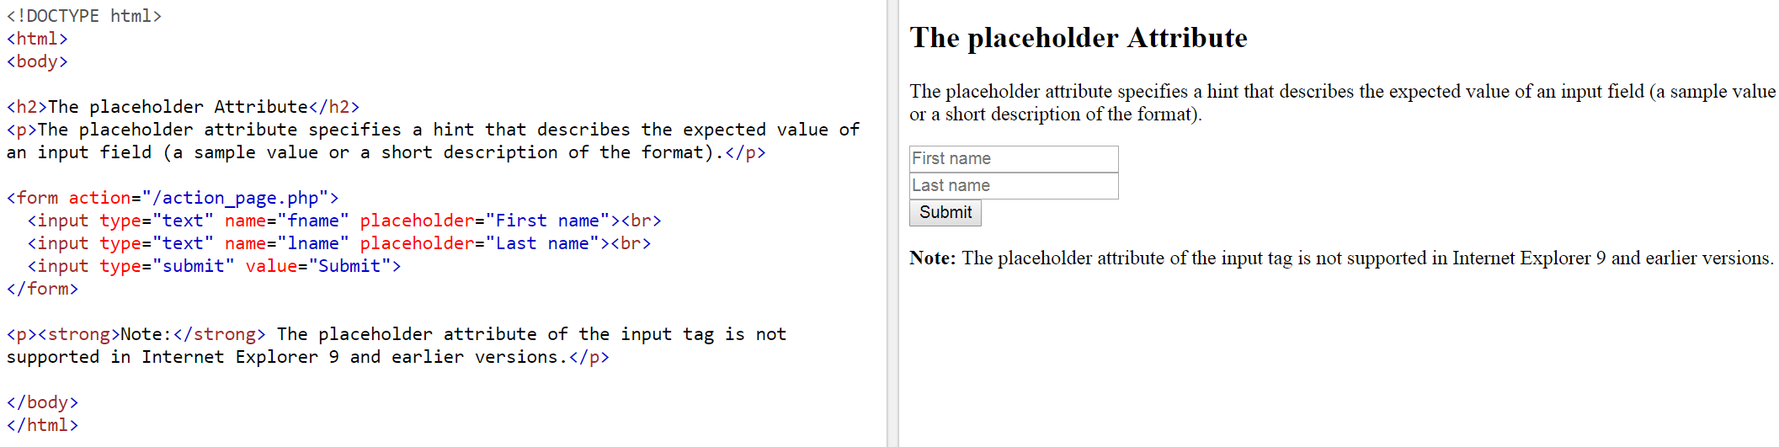

Example of Read Only Attribute: <https://www.w3schools.com/html/tryit.asp?filename=tryhtml_input_attributes_readonly>

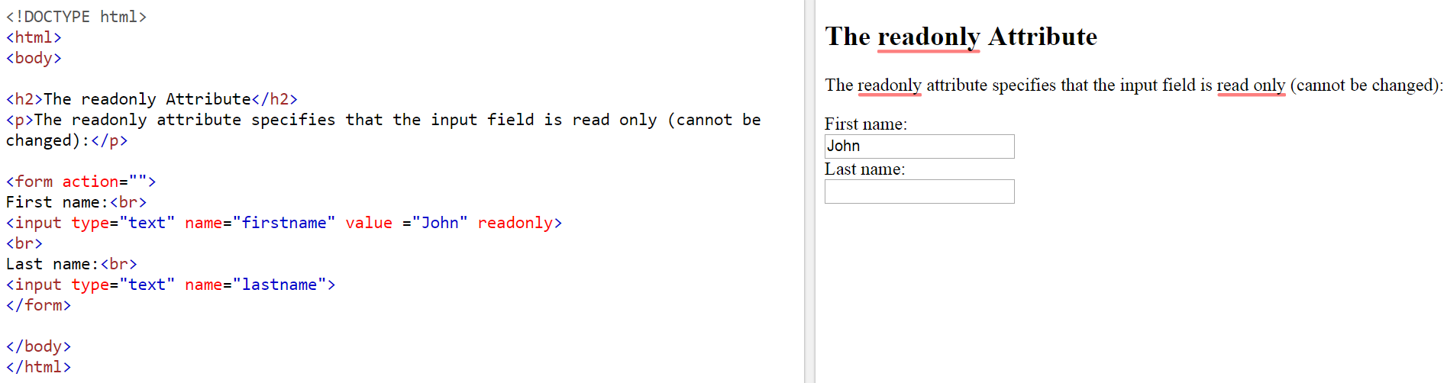

Example of email format: <https://www.w3schools.com/html/tryit.asp?filename=tryhtml_input_email>

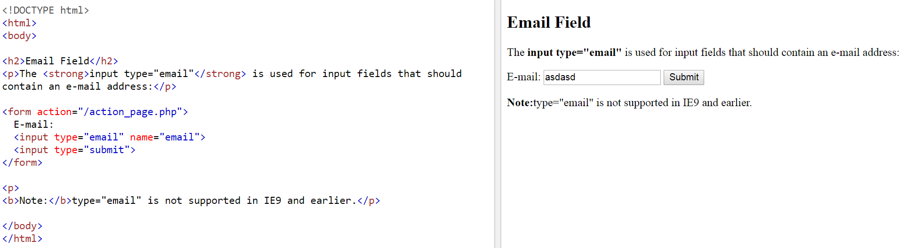

Example of password: <https://www.w3schools.com/html/tryit.asp?filename=tryhtml_input_password>

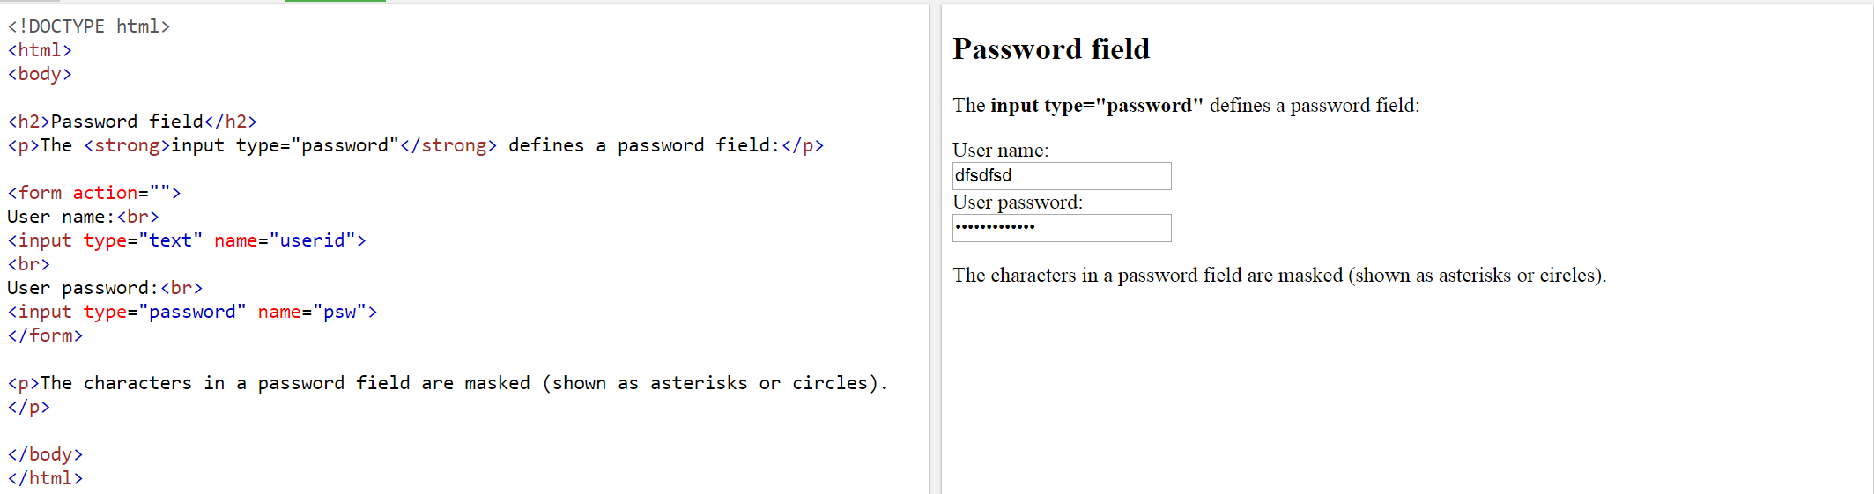

Example of fieldset: <https://www.w3schools.com/html/tryit.asp?filename=tryhtml_form_legend>

<h2>Grouping Form Data with Fieldset</h2>

<p>The fieldset element is used to group related data in a form, and the legend element defines a caption for the fieldset element.</p>

<form action="/action_page.php">

<fieldset style="width:50%">

<legend>Personal information:</legend>

<p>XXXXXXXXXXXXXXXXXXXXXXX</p>

<p>XXXXXXXXXXXXXXXXXXXXXXX</p>

<p>XXXXXXXXXXXXXXXXXXXXXXX</p>

<p>XXXXXXXXXXXXXXXXXXXXXXX</p>

<input type="submit">

</fieldset>

</form>

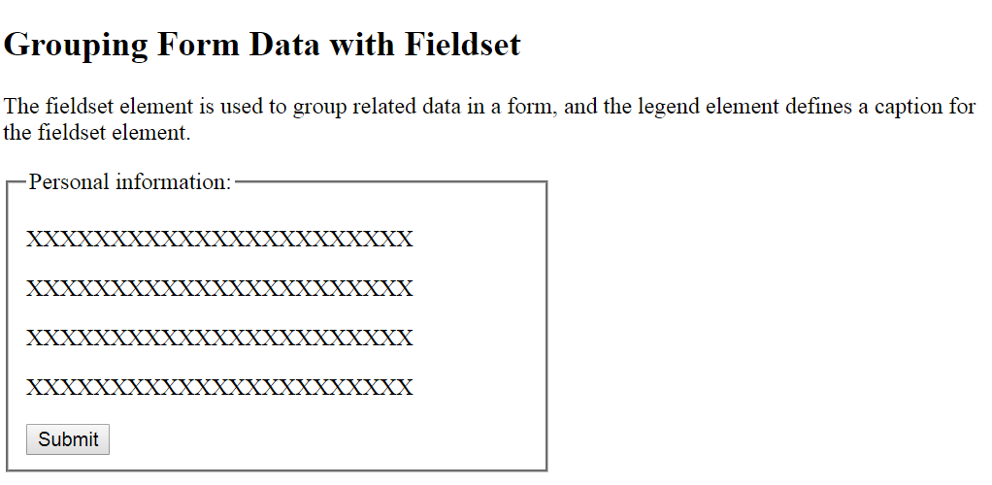

Example of Textarea 1: <https://www.w3schools.com/html/tryit.asp?filename=tryhtml_elem_textarea_style>

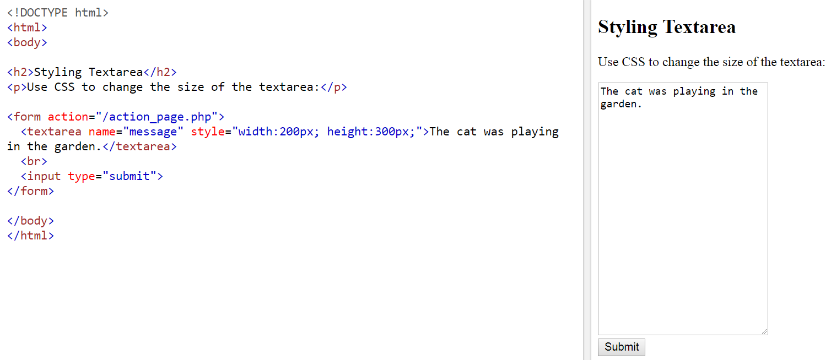

Example of Textarea 2: <https://www.w3schools.com/html/tryit.asp?filename=tryhtml_elem_textarea_style>

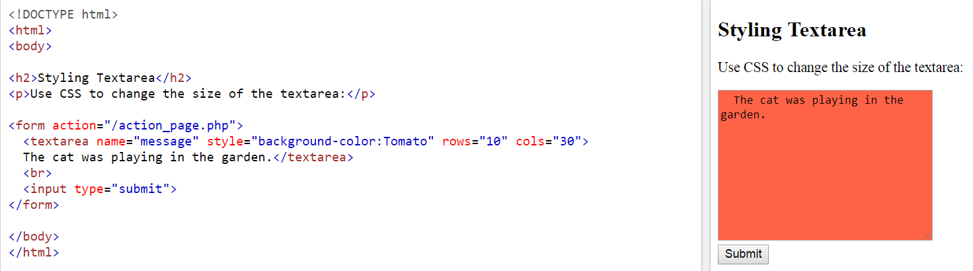

Example of alert for submission: <https://www.w3schools.com/html/tryit.asp?filename=tryhtml_elem_button>

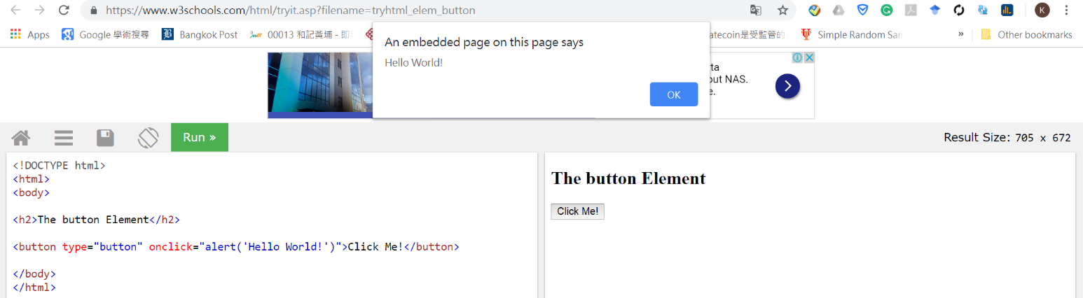

Example of Time Field: <https://www.w3schools.com/html/tryit.asp?filename=tryhtml_input_time>

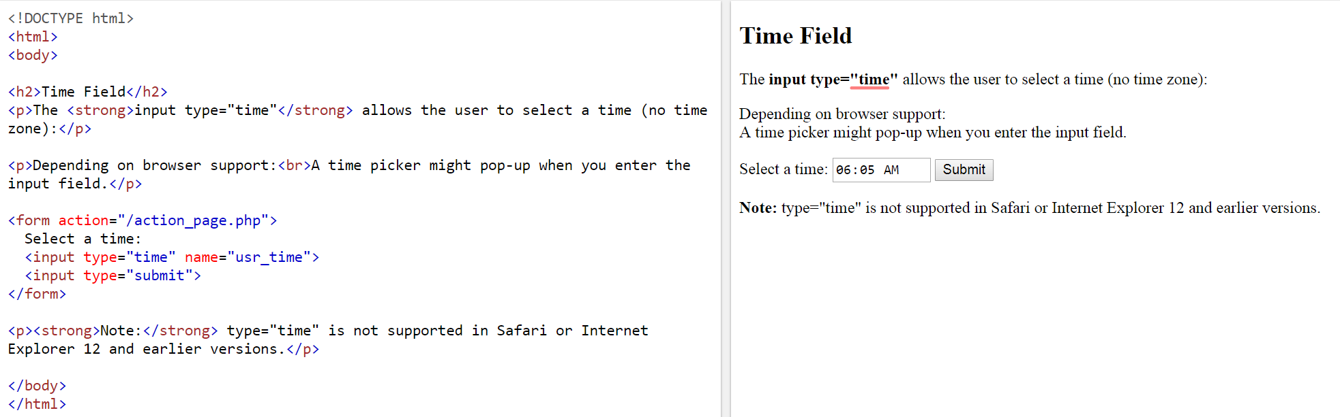

Example of calendar 1: <https://www.w3schools.com/html/tryit.asp?filename=tryhtml_input_date>

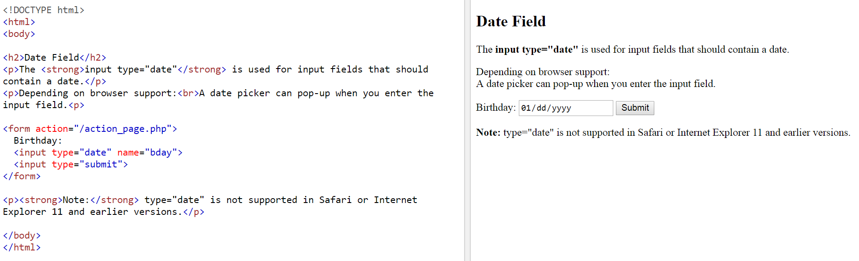

Example of calendar 2: <https://www.w3schools.com/html/tryit.asp?filename=tryhtml_input_date_max_min>

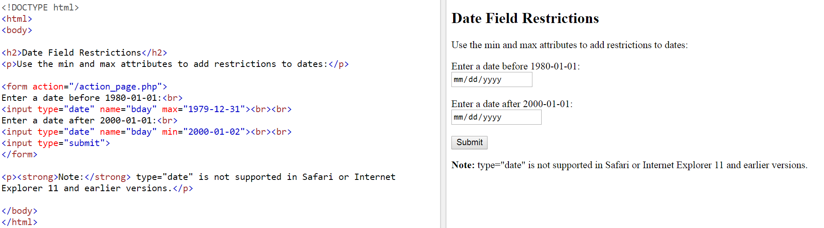

Example of calendar 3: <https://www.w3schools.com/html/tryit.asp?filename=tryhtml_input_datetime-local>

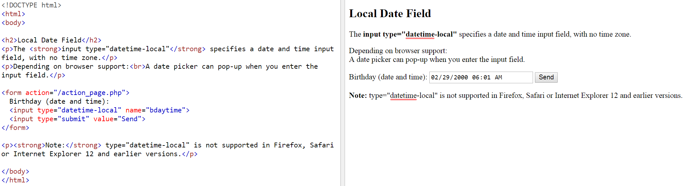

Example of Number Field: <https://www.w3schools.com/html/tryit.asp?filename=tryhtml_input_number>

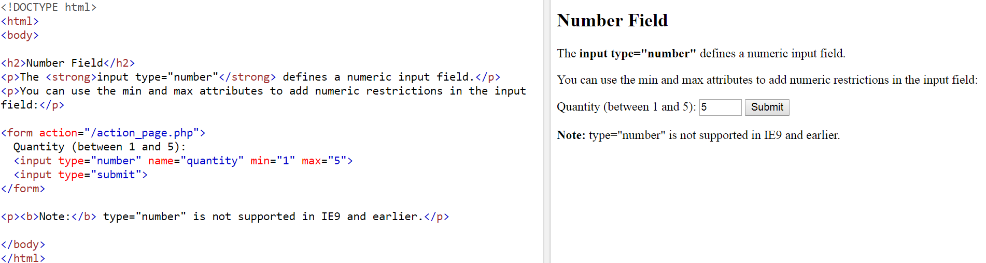

Example of Numeric Steps: <https://www.w3schools.com/html/tryit.asp?filename=tryhtml_input_number_step>

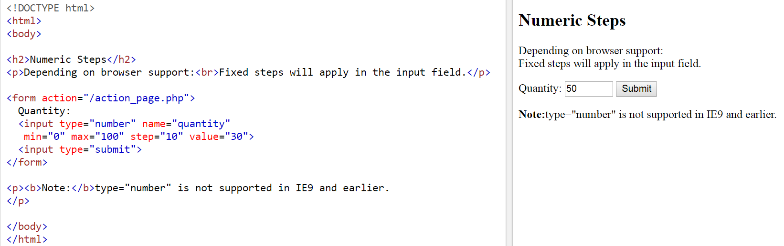

Example of URL Field: <https://www.w3schools.com/html/tryit.asp?filename=tryhtml_input_url>

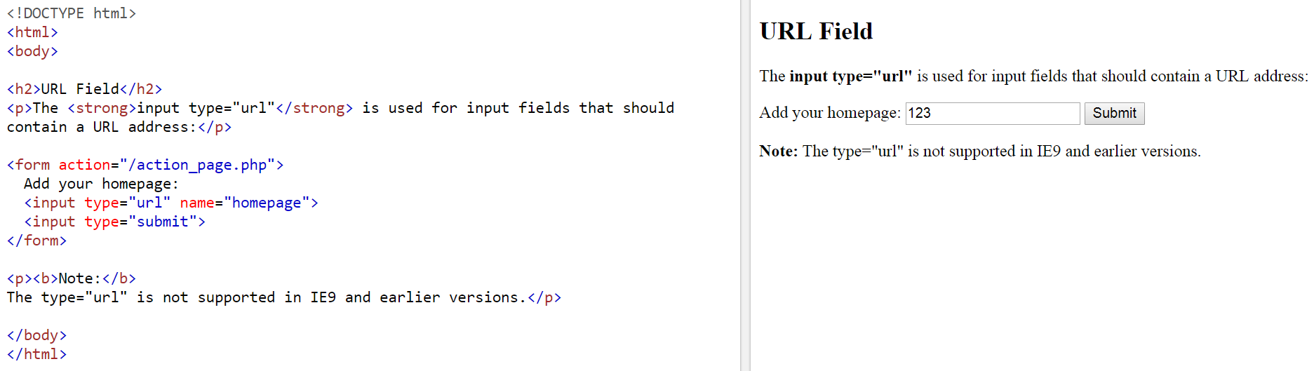

Example of radio buttons: <https://www.w3schools.com/html/tryit.asp?filename=tryhtml_form_radio>

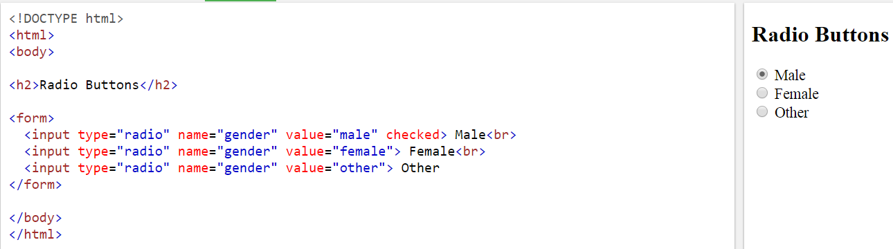

Example of checkbox buttons: <https://www.w3schools.com/html/tryit.asp?filename=tryhtml_input_checkbox>

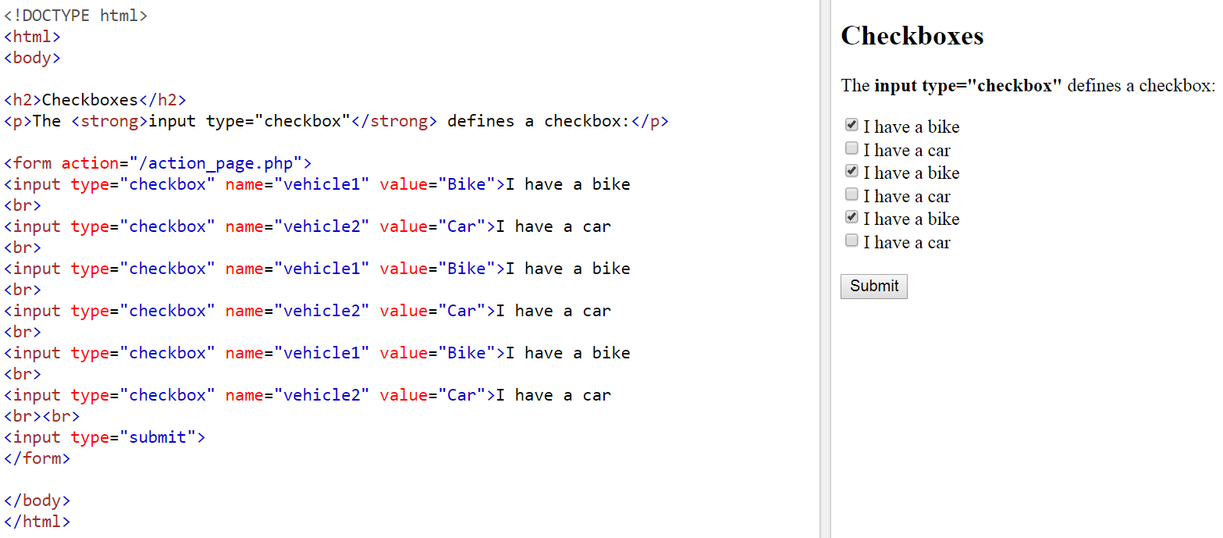

Example of drop-down list: <https://www.w3schools.com/html/tryit.asp?filename=tryhtml_elem_select_pre>

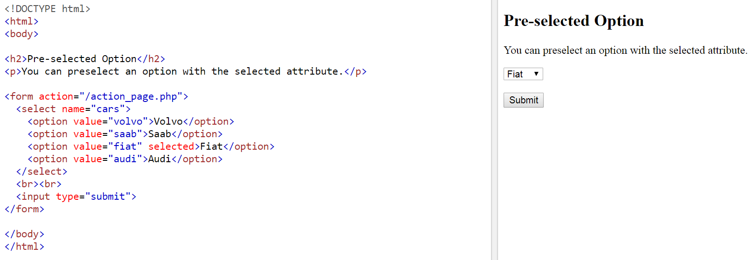

Example of <datalist> Element: <https://www.w3schools.com/html/tryit.asp?filename=tryhtml_elem_datalist>

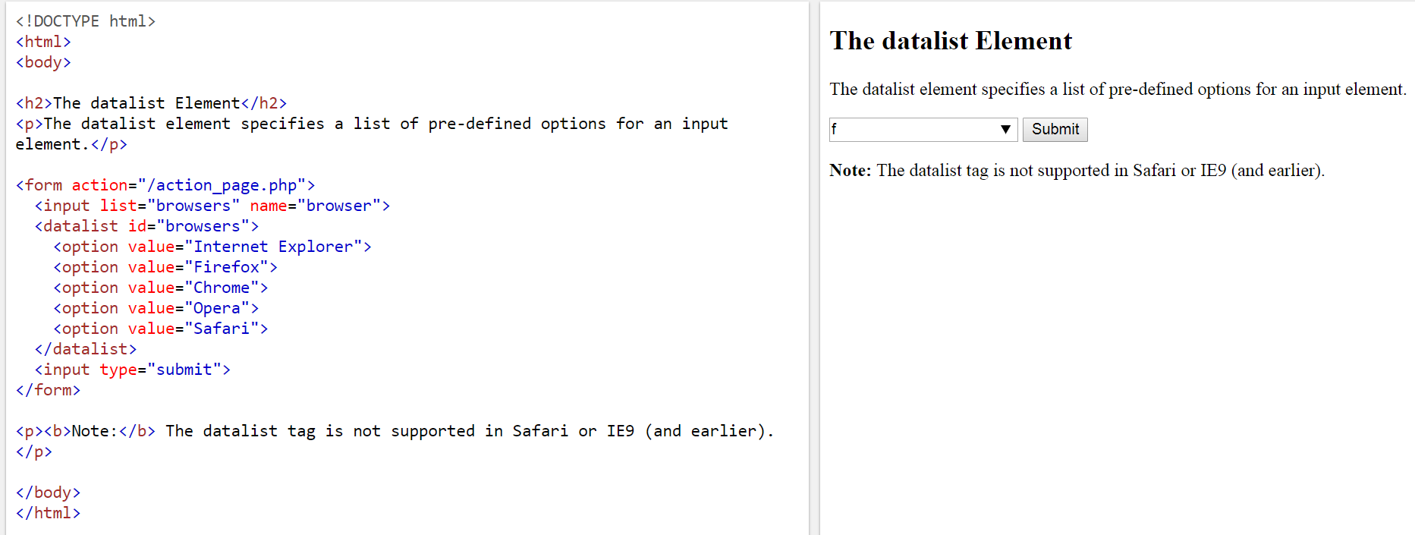

Example of Inserting image button: <https://www.w3schools.com/html/tryit.asp?filename=tryhtml5_input_height_width>

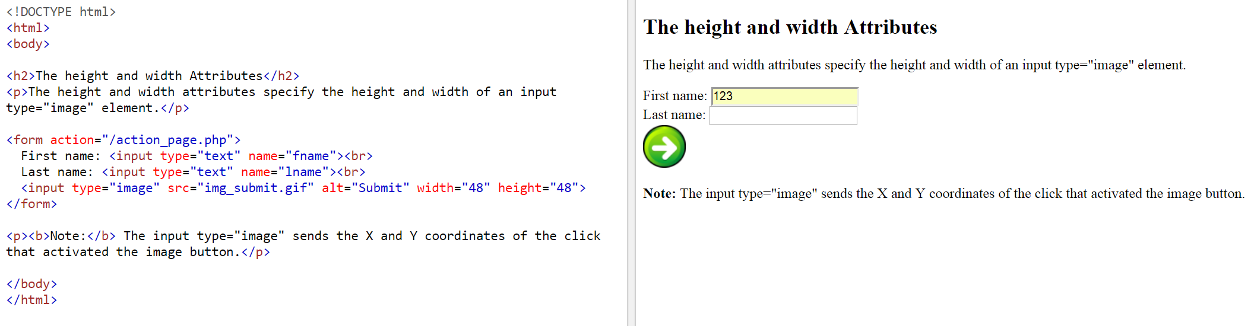

Example of file upload 1: <https://www.w3schools.com/html/tryit.asp?filename=tryhtml_input_file>

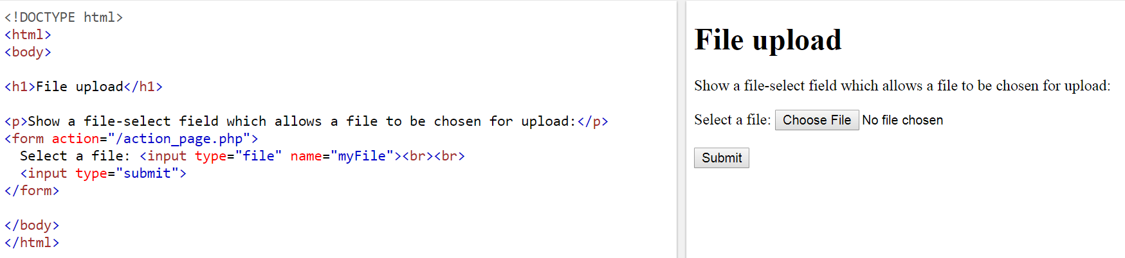

Example of file upload 2:<https://www.w3schools.com/Tags/tryit.asp?filename=tryhtml_input_accept>

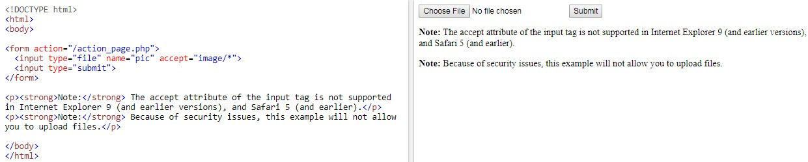

Example of reset button: <https://www.w3schools.com/html/tryit.asp?filename=tryhtml_input_reset>

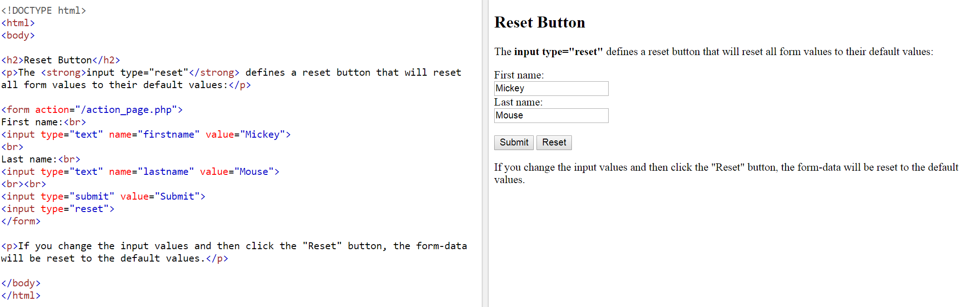

form.html in your lecture notes

