Click share -> chose Embed->Copy html code

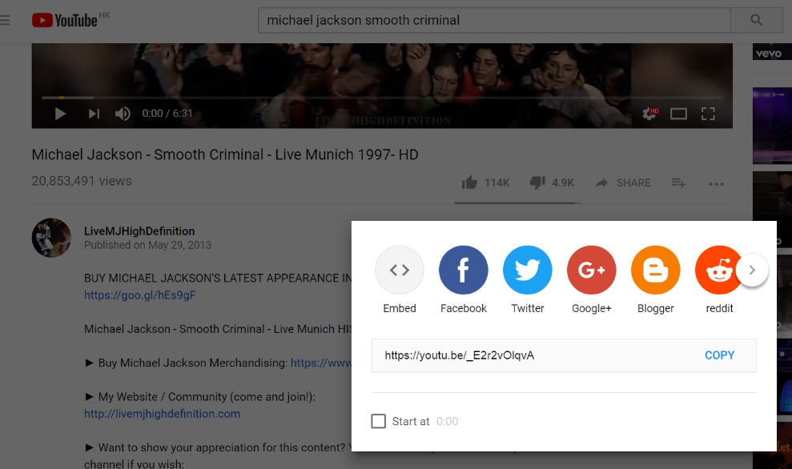

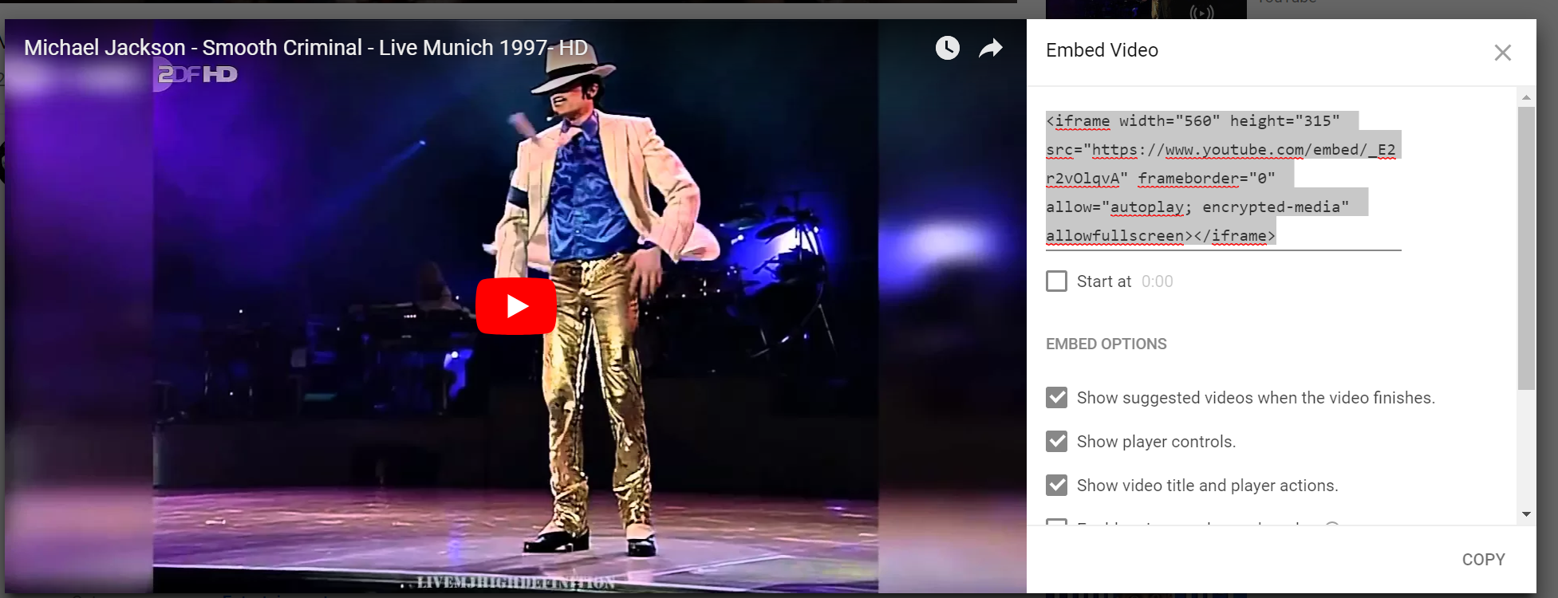

YouTube video play:

<!DOCTYPE html>

<html>

<body>

<iframe width="420" height="345" src="https://www.youtube.com/embed/tgbNymZ7vqY">

</iframe>

</body>

</html>

Loop:

<!DOCTYPE html>

<html>

<body>

<iframe width="420" height="345" src="https://www.youtube.com/embed/tgbNymZ7vqY?playlist=tgbNymZ7vqY&loop=1">

</iframe>

</body>

</html>

Google Map:

<!DOCTYPE html>

<html>

<body>

<h1>My First Google Map</h1>

<div id="map" style="width:400px;height:400px;background:yellow"></div>

<script>

function myMap() {

var mapOptions = {

center: new google.maps.LatLng(51.5, -0.12),

zoom: 10,

mapTypeId: google.maps.MapTypeId.HYBRID

}

var map = new google.maps.Map(document.getElementById("map"), mapOptions);

}

</script>

<script src="https://maps.googleapis.com/maps/api/js?key=AIzaSyBu-916DdpKAjTmJNIgngS6HL_kDIKU0aU&callback=myMap"></script>

<!--

To use this code on your website, get a free API key from Google.

Read more at: https://www.w3schools.com/graphics/google_maps_basic.asp

-->

</body>

</html>

Sources of social media posts: Twitter

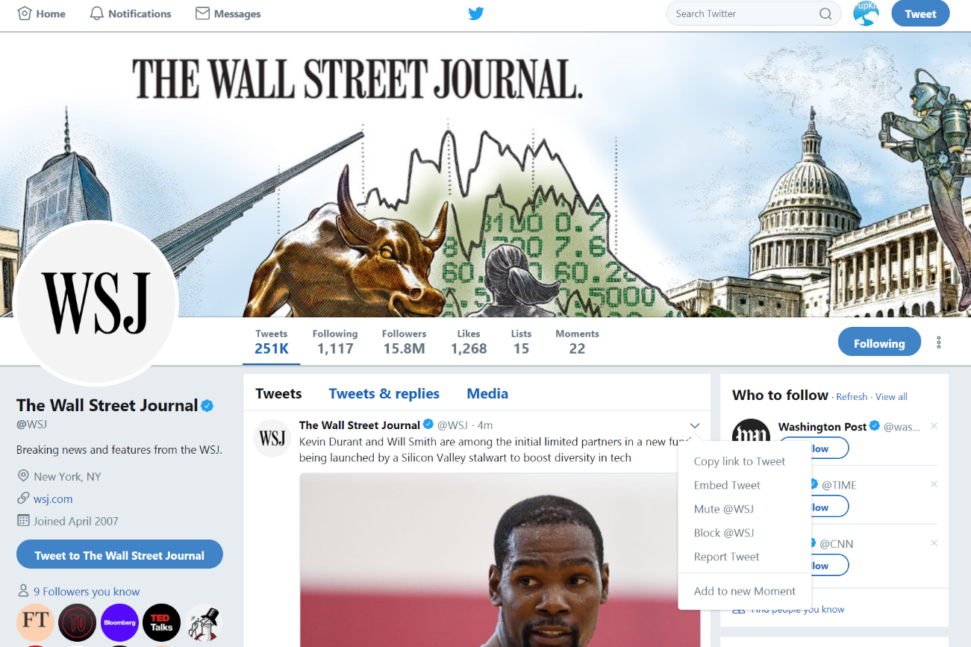

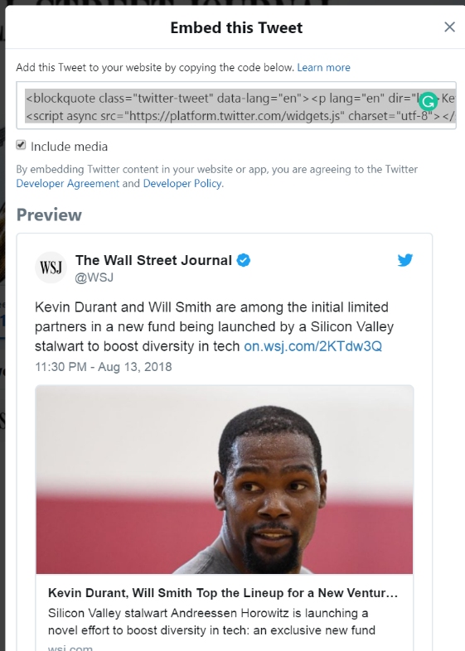

<blockquote class="twitter-tweet" data-lang="en"><p lang="en" dir="ltr">Kevin Durant and Will Smith are among the initial limited partners in a new fund being launched by a Silicon Valley stalwart to boost diversity in tech <a href="https://t.co/IBK6bZpUJR">https://t.co/IBK6bZpUJR</a></p>&mdash; The Wall Street Journal (@WSJ) <a href="https://twitter.com/WSJ/status/1029027376544538626?ref_src=twsrc%5Etfw">August 13, 2018</a></blockquote>

<script async src="https://platform.twitter.com/widgets.js" charset="utf-8"></script>

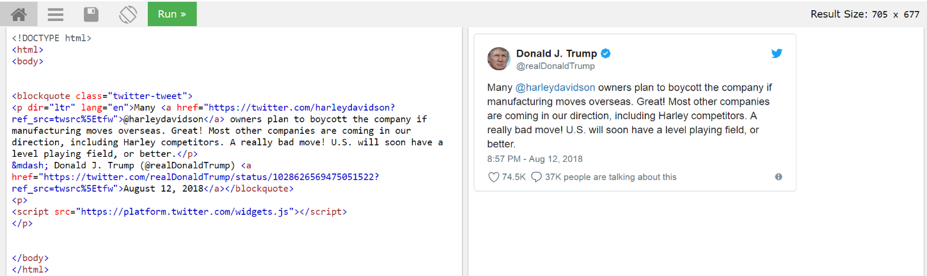

Sources of social media posts: Facebook

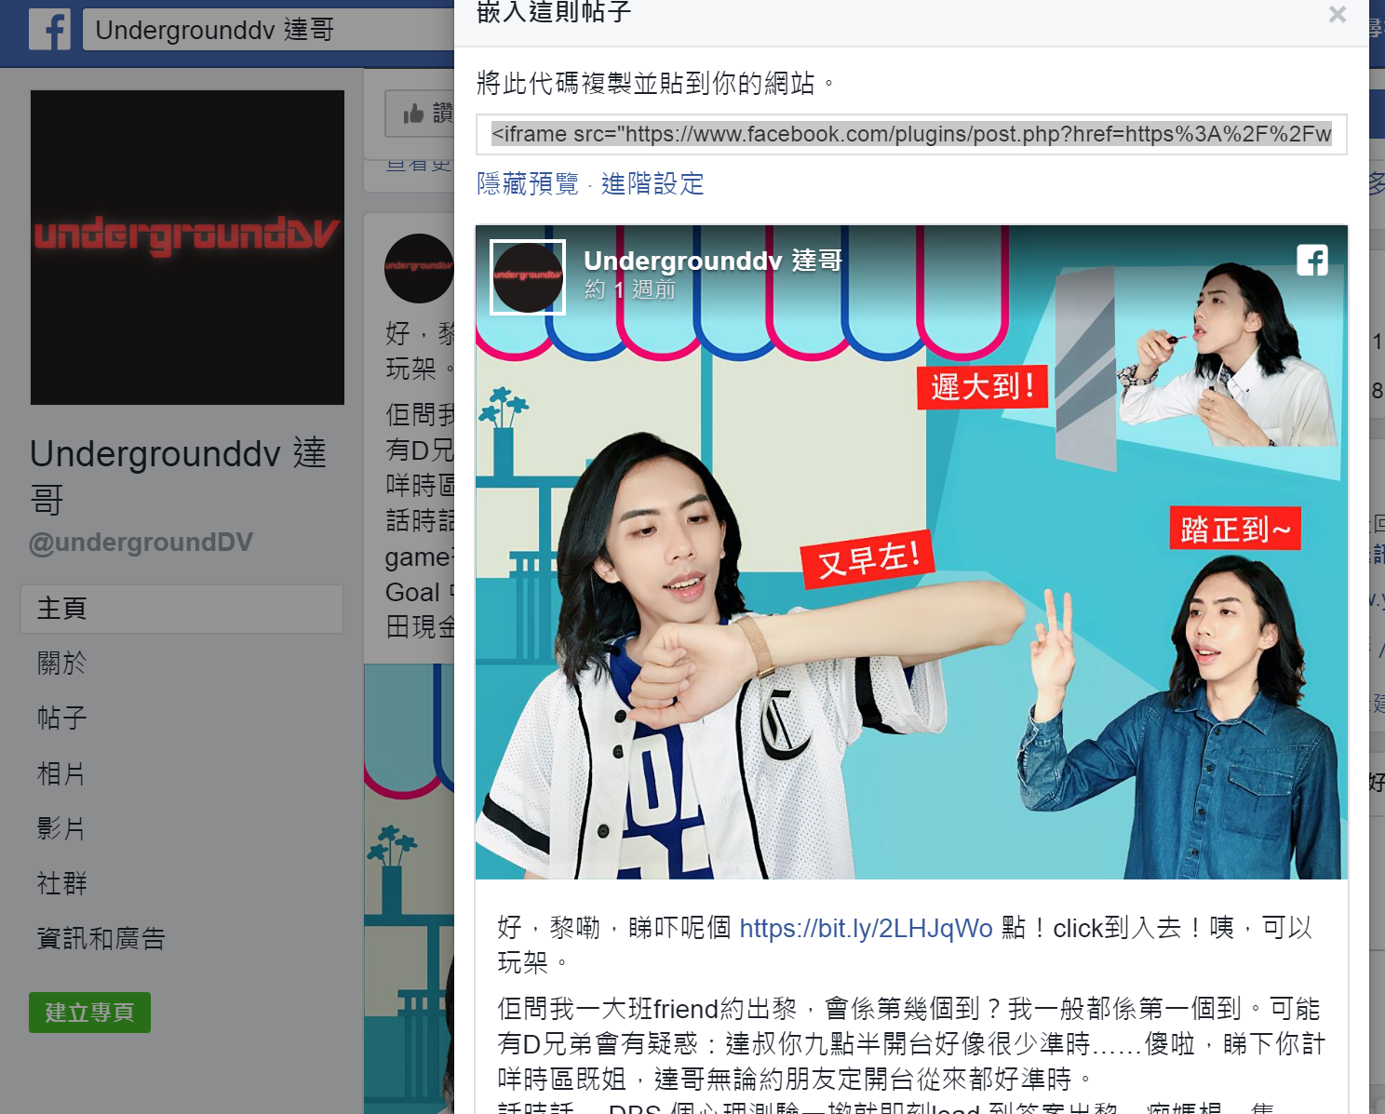

<iframe src="https://www.facebook.com/plugins/post.php?href=https%3A%2F%2Fwww.facebook.com%2FundergroundDV%2Fposts%2F10156481722837230%3A0&width=500" width="500" height="642" style="border:none;overflow:hidden" scrolling="no" frameborder="0" allowTransparency="true" allow="encrypted-media"></iframe>

<!DOCTYPE html>

<html>

<body>

<blockquote class="twitter-tweet" data-lang="en"><p lang="en" dir="ltr">Kevin Durant and Will Smith are among the initial limited partners in a new fund being launched by a Silicon Valley stalwart to boost diversity in tech <a href="https://t.co/IBK6bZpUJR">https://t.co/IBK6bZpUJR</a></p>&mdash; The Wall Street Journal (@WSJ) <a href="https://twitter.com/WSJ/status/1029027376544538626?ref_src=twsrc%5Etfw">August 13, 2018</a></blockquote>

<script async src="https://platform.twitter.com/widgets.js" charset="utf-8"></script>

<iframe src="https://www.facebook.com/plugins/post.php?href=https%3A%2F%2Fwww.facebook.com%2FundergroundDV%2Fposts%2F10156481722837230%3A0&width=500" width="500" height="642" style="border:none;overflow:hidden" scrolling="no" frameborder="0" allowTransparency="true" allow="encrypted-media"></iframe>

<br>

<iframe src="https://www.facebook.com/plugins/like.php?href=https%3A%2F%2Fdevelopers.facebook.com%2Fdocs%2Fplugins%2F&width=450&layout=standard&action=like&size=small&show_faces=true&share=true&height=80&appId" width="450" height="80" style="border:none;overflow:hidden" scrolling="no" frameborder="0" allowTransparency="true" allow="encrypted-media"></iframe>

<a class="twitter-share-button"

href="https://twitter.com/intent/tweet?text=Hello%20world">

Tweet</a>

</body>

</html>

Sources of social media like buttons: Facebook- https://developers.facebook.com/docs/plugins/like-button/#configurator

Twitter- https://developer.twitter.com/en/docs/twitter-for-websites/tweet-button/overview.html

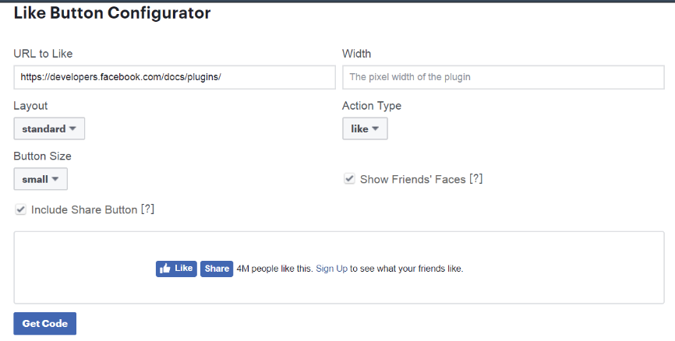

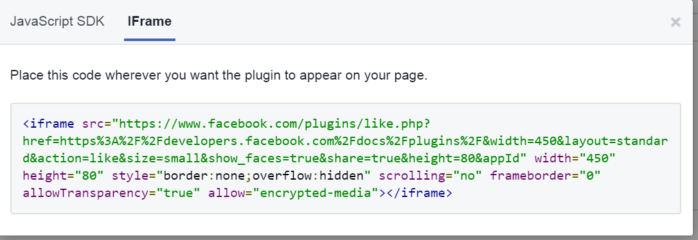

Facebook-

<iframe src="https://www.facebook.com/plugins/like.php?href=https%3A%2F%2Fdevelopers.facebook.com%2Fdocs%2Fplugins%2F&width=450&layout=standard&action=like&size=small&show_faces=true&share=true&height=80&appId" width="450" height="80" style="border:none;overflow:hidden" scrolling="no" frameborder="0" allowTransparency="true" allow="encrypted-media"></iframe>

Twitter-

<a class="twitter-share-button"

href="https://twitter.com/intent/tweet?text=Hello%20world">

Tweet</a>